An
Industrial Oriented MAJOR Project
“E-COMMERCE PRODUCT RECOMMENDATION SYSTEM”
Submitted to Jawaharlal Nehru Technological University, Hyderabad in partialfulfillment of the requirement for the award of the Under Graduate Degree.
BACHELOR OF TECHNOLOGY
in
COMPUTER SCIENCE AND ENGINEERING

Submitted By
“GHATAM BALA SRIRAM DAKSHRAJ” (22QA1A0534)
“KANNEPELLI RAKESH” (22QA1A0549)
“GOLYALA ADITHYA AMBADAS” (22QA1A0538)
“DAMAMI SAI TEJ” (22QA1A0522)
“GODIKYA AKASH” (22QA1A0535)

Under the guidance of
Mrs. B. LAVANYA, _{M.Tech}
Assistant Professor
DEPARTMENT OF COMPUTER SCIENCE & ENGINEERING

BRILLIANT INSTITUTE OF ENGINEERING AND TECHNOLOGY
Abdullapurmet (V), Abdullapurmet (M), R.R.Dist, Pin-501505
Accredited by NAAC with ‘A’ Grade
(Affiliated to JNTU Hyderabad)
2022-2026
BRILLIANT INSTITUTE OF ENGINEERING & TECHNOLOGY
( Approved by AICTE, New Delhi & Affiliated to JNTU, Hyderabad )
Accredited by NAAC with ‘A’ Grade
Abdullapurmet (V & M), R.R (Dist). Telangana -501505
Ph: 040- 23437788,Fax: 040-23437776
www.b-iet.ac.in/



CERTIFICATE

This is to certify that the Major project report entitles “E-COMMERCE PRODUCT RECOMMENDATION SYSTEM” is being submitted by “GHATAM BALA SRIRAM DAKSHRAJ (22QA1A0534)”, “KANNEPELLI RAKESH (22QA1A0549)”, “GOLYALA ADITHYA AMBADAS (22QA1A0538)”, “DAMAMI SAI TEJ (22QA1A0522)”, “GODIKYA AKASH (22QA1A0535)”, in B. Tech from Computer Science and Engineering is a record Bonafide work carried out by us. The results embodied in this project have not submitted to any other University for the award of any degree.

INTERNAL GUIDE HEAD OF THE DEPARTMENT

Mrs. B. LAVANYA,M.Tech Dr. J. REDDAPPA REDDY, Ph.D
Assistant Professor Associate Professor,
HOD, CSE.

PRINCIPAL
Dr. SHAIK RUSTHUM, Ph.D EXTERNAL EXAMINER
ACKNOWLEDGEMENT
This report will certainly not be completed without due acknowledgements paid to all those who have helped us in doing our project work.
We are thankful to our project internal guide Mrs. B. LAVANYA, M.Tech Assistant professor for giving us moral support and conducting seminars smoothly to us throughout this project work.
It is our privilege to thank Dr. J. REDDEPPA REDDY, Associate professor – Head of the Department, CSE. For his encouragement during the progress of this project work.
We are thankful to both Teaching and non-teaching staff members of CSE DEPARTMENT for their kind cooperation and all sorts of help to bring out this project work successfully.
We derive great pleasure in expressing our sincere gratitude to our principal Dr. SHAIK RUSTHUM for his timely suggestions, which helped us to complete this work successfully.
We are thankful to BRILLIANT INSTITUTE OF ENGINEERING AND TECHNOLOGY for providing required facilities during our project work. We would like to thank our parents and my friends for being supportive all the time, and we are very much obliged to them.

GHATAM BALA SRIRAM DAKSHRAJ 22QA1A0534
KANNEPELLI RAKESH 22QA1A0549
GOLYALA ADITHYA AMBADAS 22QA1A0538
DAMAMI SAI TEJ 22QA1A0522
GODIKYA AKASH 22QA1A0535

DECLARATION

We hereby declare that the project report entitled “E-COMMERCE PRODUCT RECOMMENDATION SYSTEM” carried under the guidance of Mrs. B. LAVANYA, M.Tech ASSISTANT PROFFESER, is being submitted in partial fulfillment of the academic requirements for the degree of Bachelors of Technology in Computer Science Engineering.This is a record of bonafide work carried out by us and the results embodied in this project have not been reproduced or copied from any source. The results embodied in this project have not been submitted to any other university or institute for the award of any other degree or diploma.

GHATAM BALA SRIRAM DAKSHRAJ 22QA1A0534
KANNEPELLI RAKESH 22QA1A0549
GOLYALA ADITHYA AMBADAS 22QA1A0538
DAMAMI SAI TEJ 22QA1A0522
GODIKYA AKASH 22QA1A0522

CONTENTS
S NO. TOPICS PAGE NO

Abstract i
List of Figures ⅱ
List of Tables ⅱⅰ
List of Screenshots ⅳ
List of Abbreviations v

1. INTRODUCTION 1-3
1.1 Motivation
1.2 Problem Statement &Definition
1.3 Objectives
1.4 Limitations of project

2. LITERATURE REVIEW 4-7
2.1 Evolution of E-Commerce System
2.2 Shortcomings Of Existing E-Commerce System
2.3 Modern E-Commerce Recommendation Approaches
2.4 Technologies Used In Recommendation Systems
2.5 Challenges In Recommendation System
2.6 Compartive Analysis Of E-Commerce System
2.7 Need for Proposed System

3. PROBLEM STATEMENT & REQUIREMENTS 8-12
3.1 Problem Statement
3.2 System Requirements : Functional & Non-Functional Requirements
3.3 Functional Requirements
3.4 Non-Functional Requirements
3.5 Hardware Requirements
3.6 Software Requirements
3.7 Feasibility Analysis

4. PROPOSED APPROACH / METHODOLOGY 13-19
4.1 Overview Of End-to-End System
4.2 Detailed Algorithm
4.3 System Architecture
4.4 Data Flow Diagram
4.5 Use Case Diagram
4.6 Class Diagram
4.7 Activity Diagram
4.8 Sequence Diagram

5. SYSTEM ARCHITECTURE & DESIGN 20-25
5.1 Overview
5.2 System Architecture
5.3 System Design Approach
5.4 Database Design
5.5 API Design
5.6 User Interface Design
5.7 System Workflow Design
5.8 Advantages Of Design

6. IMPLEMENTATION 26-48
6.1 Overview
6.2 Frontend Implementation
6.3 Backend Implementation
6.4 Dependencies
6.5 Environment
6.6 Database Implementation
6.7 Recommendation Engine Implementation
6.8 Performance Optimization

7. TESTING 49-52
7.1 Overview
7.2 Objectives Of Testing
7.3 Types Of Testing
7.4 Testing Tools Used
7.5 Performance Analysis
7.6 Results Of Testing

8. EXPERIMENTS AND RESULTS 53-61
8.1 Overview
8.2 Experimental Setup
8.3 Module Wise Result
8.3.1 Backend Terminal Running
8.3.2 Frontend Terminal Running
8.3.3 Home Page
8.3.4 Product Page
8.3.5 Featured Products
8.3.6 Recommended Products
8.3.7 Cart page
8.3.8 Payment Page
8.3.9 About and Contact Page
8.4 Performance Analysis
8.5 Result Analysis
8.6 Advantages Observed

9. FUTURE WORK AND EXTENSION 62-66
10. CONCLUSION 67-69
REFERENCES 70
ABSTRACT
The rapid growth of e-commerce platforms has led to an overwhelming number of products available to users, making it difficult for customers to find relevant items efficiently. This project presents the design and development of an E-commerce Product Recommendation System aimed at improving user experience by providing personalized product suggestions.
The system is developed using a modern web-based architecture consisting of a React-based frontend, a Node.js backend, and a MongoDB database.
The frontend provides an interactive user interface for browsing products, adding items to the cart, and viewing recommendations.
The backend handles API requests, manages business logic, and communicates with the database. The system tracks user interactions and utilizes basic recommendation techniques to suggest relevant products dynamically.
Key features of the system include product browsing, search functionality, cart management, and a recommendation module that enhances user engagement. The application also includes a simple payment flow simulation and efficient handling of user activities.
The proposed system demonstrates how recommendation techniques can be effectively integrated into e-commerce platforms to improve usability and customer satisfaction. This project serves as a foundation for further enhancements such as advanced machine learning-based recommendations and real-time personalization.
The results of the project indicate that the system successfully enhances usability and helps users discover relevant products quickly. This project can be further extended by incorporating advanced machine learning algorithms, real-time recommendation techniques, and secure payment gateway integration to improve performance and scalability.
LIST OF FIGURES
Fig .NO. | NAME OF THE FIGURE | PAGE NO.
1 | 4.4 DATA FLOW DIAGRAM | 15
2 | 4.5 USE CASE DIAGRAM | 16
3 | 4.6 CLASS DIAGRAM | 17
4 | 4.7 ACTIVITY DIAGRAM | 18
5 | 4.8 SEQUENCE DIAGRAM | 19
6 | 5.2 SYSTEM ARCHITECTURE | 21

LIST OF TABLES
Table NO. | NAME OF THE TABLE | PAGE NO.
1 | 2.3 MODERN E-COMMERCE  RECOMMENDATION APPROACH | 5
2 | 2.6 COMPARATIVE ANALYSIS OF E-COMMERCE SYSTEM | 6
3 | 3.2 FUNCTONAL & NON-FUNCTIONAL REQUIREMENTS | 9

LIST OF SCREEN SHOTS
Screen NO. | NAME OF THE SCREENSHOTS | PAGE NO.
1 | BACKEND TERMINAL RUNNING | 54
2 | FRONTEND TERMINAL RUNNING | 55
3 | HOME PAGE | 55
4 | PRODUCT PAGE | 56
5 | FEATURED PRODUCTS | 56
6 | RECOMMENDED PRODUCTSC | 57
7 | CART PAGE | 57
8 | PAYMENT FLOW | 58
9 | ABOUT&CONTACT PAGE | 60

SYMBOLS & ABBREVIATIONS
TERM | ABBREVIATION
API | Application Programming Interface
DB | Data Base
DFD | Data Flow Diagram
HTML | HyperText Markup Language
HTTP | HyperText Transfer Protocol
HTTPS | HyperText Transfer Protocol Secure
ML | Machine Learning
MongoDB | Document Based Database
Node.js | JavaScript Runtime Environment
REST | Representational State Transfer
URL | Uniform Resource Locator
JSON | JavaScript Object Notation
CSS | Cascading Style Sheets
JS | JavaScript
CRUD | Create,Read,Update,Delete

CHAPTER- 1
INTRODUCTION
1.1 Motivation
The rapid growth of e-commerce platforms has transformed the way people shop, making online purchasing more convenient, accessible, and efficient. With thousands of products available across various categories, users often face difficulty in finding relevant items that match their preferences. Traditional e-commerce systems rely heavily on manual search and browsing, which can be time-consuming and may not always provide accurate results. This leads to poor user experience and reduced customer satisfaction.
The development of this system has practical applications in various domains:
• Online Shopping Platforms: Personalized product suggestions for better user experience
• Retail Businesses: Increased sales through targeted recommendations
• Digital Marketplaces: Improved product discoverability• Customer Analytics: Understanding user behaviour and preferences
This project represents an important step toward enhancing the efficiency and intelligence of modern e-commerce platforms by integrating recommendation technologies with full-stack web development.

1.2 Problem Statement & Definition
The E-Commerce Product Recommendation System can be defined as a web-based platform that enables users to browse, search, and purchase products while receiving personalized recommendations based on their behavior and preferences. The system integrates user data, product data, and recommendation algorithms to provide relevant suggestions in real time.
The core problem addressed by this system is the lack of intelligent product discovery in traditional e-commerce platforms. Most systems depend on manual searching and static product listings, which do not adapt to individual user preferences. This results in inefficient browsing, reduced engagement, and missed sales opportunities.
The key challenges involved include:
- Providing personalized recommendations based on user behavior
- Handling large volumes of product and user data efficiently
- Ensuring secure user authentication and data protection
- Implementing real-time recommendation mechanisms
- Maintaining scalability to support multiple users simultaneously
- Improving user engagement and satisfaction
To address these challenges, the system is designed as an end-to-end solution that integrates frontend user interfaces, backend logic, database management, and recommendation algorithms. The use of REST APIs enables smooth communication between components, while modern technologies ensure efficient and secure data handling.

1.3 Objectives
The primary objective of this project is to design and develop an intelligent E-Commerce Product Recommendation System that enhances user experience through personalized product suggestions.
Secondary objectives include:
- Personalization: To provide customized product recommendations based on user behavior
- Data Management: To efficiently store and manage user and product data
- Recommendation Engine: To implement filtering algorithms for accurate suggestions
- User Experience: To design a responsive and intuitive user interface
- Security Implementation: To ensure secure authentication using JWT
- Scalability: To develop a system capable of handling large datasets and multiple users
- Real-Time Processing: To provide instant recommendations and updates
- Order Management: To enable users to add products to cart and place orders
- Performance Optimization: To ensure fast loading and smooth system performance

1.4 Limitations of the Project
Despite its advantages, the E-Commerce Product Recommendation System has certain limitations:
- Dependence on User Data: Recommendations depend on user activity; new users may receive less accurate suggestions
- Cold Start Problem: Difficulty in providing recommendations for new users or products
- Internet Dependency: Requires stable internet connection for operation
- Limited Recommendation Accuracy: Basic algorithms may not always provide perfect results
- Scalability Constraints: Performance may degrade with extremely large datasets
- Security Risks: Requires continuous monitoring to prevent data breaches
- No Advanced AI Integration: The system may not include deep learning-based recommendations

CHAPTER- 2
LITERATURE REVIEW
2.1 Evolution of E-Commerce Systems
The e-commerce industry has experienced significant transformation over the years, evolving from simple online catalogs to highly intelligent and personalized digital marketplaces. Initially, e-commerce platforms were basic web applications that allowed users to view products and place orders online. These early systems lacked interactivity, personalization, and advanced functionality, making the user experience limited and less engaging.
In the early stages, users were required to manually search for products using categories and keyword-based queries. These systems did not provide any intelligent assistance, which made product discovery difficult, especially when dealing with large inventories. As the number of products increased, it became increasingly challenging for users to find relevant items efficiently.
With the advancement of web technologies, e-commerce platforms started incorporating dynamic features such as user accounts, shopping carts, and order management systems. These improvements enhanced usability and allowed users to interact more effectively with the platform. However, the systems still lacked personalization and intelligent recommendations.
In the early stages, users were required to manually search for products using categories and keyword-based queries. These systems did not provide any intelligent assistance, which made product discovery difficult, especially when dealing with large inventories. As the number of products increased, it became increasingly challenging for users to find relevant items efficiently.

2.2 Shortcomings of Existing E-Commerce Systems
Despite the advancements in e-commerce technologies, many existing systems still face several limitations that affect their performance and user experience. Traditional e-commerce platforms rely heavily on manual search and static product listings, which do not adapt to individual user preferences.
One of the major limitations is the lack of personalization. Many systems display the same products to all users regardless of their interests or behaviour. This reduces the effectiveness of the platform and leads to poor user engagement. Users may struggle to find relevant products, resulting in frustration and decreased satisfaction.
Another significant issue is inefficient product discovery. As product catalogs grow larger, users are required to spend more time searching and filtering items. Without intelligent recommendations, users may miss products that match their preferences.

2.3 Modern E-Commerce Recommendation Approaches
Technique | Working Principle | Advantages | Limitations
Content Based Filtering | Recommends Based On Product similarity | Simple,No Need For Other users | Limited Diversities
Collaborative Filtering | Based On Similar Users Behavior | Highly Personalised | Needs Large Data
Hybrid Approach | Combines Both Methods | High Accuracy & Flexibility | More Complex
AI-Based Models | Uses ML Algorithms | Very Accurate Predictions | High Computational cost

TABLE NO.1

2.4 Technologies Used in Recommendation Systems
The development of modern recommendation systems relies on advanced technologies and frameworks that enable efficient data processing and system scalability.
Frontend technologies such as React.js are used to create dynamic and responsive user interfaces. These interfaces allow users to interact with the system smoothly and efficiently.
Backend technologies such as Node.js and Express.js handle business logic, API development, and communication between system components. These technologies ensure fast and reliable processing of user requests.
MongoDB is used as the database for storing user data, product information, and interaction history. It provides efficient data storage and retrieval, enabling the system to handle large datasets.
RESTful APIs facilitate communication between frontend and backend components, ensuring real-time data exchange. JWT authentication is used to secure user access and protect sensitive data.
Recommendation algorithms process user data and generate personalized suggestions. These algorithms play a crucial role in improving system performance and user experience.

2.5 Challenges in Recommendation Systems
Despite advancements, recommendation systems face several challenges that affect their performance and accuracy.
Cold start problem is a major issue where the system lacks sufficient data for new users or products. This makes it difficult to generate accurate recommendations initially.
Data sparsity occurs when user interaction data is limited, reducing the effectiveness of recommendation algorithms.
Scalability is another challenge, as the system must handle large volumes of data and user requests efficiently. Poor scalability can lead to performance degradation.
Privacy concerns are critical, as user data must be protected from unauthorized access. Systems must implement strong security measures to ensure data safety.

2.6 Comparative Analysis of E-Commerce Systems
System | Type | Approach | Limitations | Improvements in Proposed Systems
Traditional | E-Commerce | Manual Browsing | No Personalisation | Intelligent Recommendation
Basic | Online Store | Static Suggestions | Limited Accuracy | Dynamic Personalized System
Advanced | Platforms | Data-Driven Systems | Complex And Costly | Efficient Scalable Architecture
Modern AI Systems | MLBased Recommendations | High Computational Cost | Optimized Hybrid Model | ------

TABLE NO.2
2.7 Need for Proposed System
The analysis of existing systems clearly indicates the need for an intelligent, scalable, and efficient recommendation system. The proposed E-Commerce Product Recommendation System addresses these requirements by integrating modern web technologies and recommendation algorithms.

CHAPTER- 3
PROBLEM STATEMENT & REQUIREMENTS
3.1 Problem Statement
In today’s digital era, e-commerce platforms have become an essential part of daily life, allowing users to purchase products conveniently from anywhere. However, as the number of products available online continues to grow exponentially, users often face significant challenges in finding relevant items that match their preferences. Traditional e-commerce systems rely heavily on manual search, category navigation, and static product listings, which are inefficient and time-consuming.
Scalability is also a major concern in e-commerce systems. As the number of users and products increases, the system must handle large volumes of data efficiently. Poor system design can result in slow response times, delays in product loading, and reduced system performance.
Security is another important aspect. E-commerce platforms handle sensitive user data such as personal information and payment details. Any vulnerability in the system can lead to data breaches and loss of user trust. Therefore, secure authentication and data protection mechanisms are essential.
Furthermore, many systems fail to provide real-time recommendations. Delays in processing user data can lead to outdated or irrelevant suggestions, reducing the effectiveness of the recommendation engine.

3.2 System Requirements: Functional and Non-Functional Requirements
Functional |  | Non Functional
Requirements | Description | Requirements | Description
Product Management | Add,Update,Delete Products | Security | Data Encryption & Secure APIs
Recommendation Engine | Suggest Products Based On User Behaviour | Scalability | Handle Large Users&Datasets
Cart & Order | Add To Cart & Place Orders | Usability | Easy Navigation & UI
Payment Integration | Secure Transaction Handling | Reliability | Consistant & Error-Free Operation

TABLE NO.3

3.3 Functional Requirements
3.3.1 Product Management
• Administrators must be able to add, update, and delete products
• Each product should have attributes such as name, category, price, and description
• Products should be stored securely in the database
• The system should support product categorization
3.3.2 Product Browsing and Search
• Users must be able to browse products by category
• The system should support keyword-based search
• Filtering options such as price, category, and ratings should be available
3.3.3 Recommendation Engine
• The system must analyse user behaviour such as browsing and purchases
• It should recommend products based on user preferences
• Content-based filtering should be implemented
• Collaborative filtering should be supported
3.3.4 Cart and Order Management
• Users must be able to add products to cart
• The system should allow updating and removing items from cart
• Users must be able to place orders
• Order details should be stored in the database
3.3.5 Payment Integration
• The system should integrate with payment gateways
• Secure payment processing must be ensured
• Transaction status should be displayed
• The system should support multiple payment methods
• Payment data must be protected
3.3.6 User Activity Tracking
• The system should track user browsing history
• Purchase history should be recorded
• User interactions should be analysed
• Data should be used for recommendation improvement

3.4 Non-Functional Requirements
3.4.1 Security
• The system must ensure secure authentication using JWT
• Data encryption must be implemented
• Sensitive data should be protected
• The system should prevent cyber attacks
• Secure API communication must be ensured
3.4.2 Performance
• The system should provide fast response times
• It must handle multiple users simultaneously
• Recommendations should be generated quickly
• System latency should be minimized

3.4.3 Scalability
• The system should support large datasets
• It must handle increasing users efficiently
• Cloud deployment should support scalability
3.4.4 Reliability
• The system must ensure consistent performance
• Data should be stored reliably
• System downtime should be minimize
3.4.5 Usability
• The interface should be user-friendly
• Navigation should be simple
• The system should provide clear feedback
3.4.6 Maintainability
• The system should be easy to maintain
• Code should follow modular design
• Future enhancements should be supported

3.5 Hardware Requirements
• A computer or laptop with minimum 4GB RAM
• Processor: Intel i3 or higher
• Stable internet connection
• Optional: Cloud server for deployment

3.6 Software Requirements
• Frontend: React.js
• Backend: Node.js with Express.js
• Database: MongoDB
• Authentication: JWT
• Recommendation Algorithms
• Payment Gateway Integration
• Tools: VS Code, Postman
• Browser: Chrome or modern browser

3.7 Feasibility Analysis
3.7.1 Technical Feasibility
The project is technically feasible as it uses modern technologies such as React, Node.js, and MongoDB. These technologies support scalable and efficient web application development. Recommendation algorithms can be implemented using available libraries and custom logic.
3.7.2 Economic Feasibility
The development cost is low as the system uses open-source tools and technologies. Cloud services can be used with minimal cost, making the project economically viable.
3.7.3 Operational Feasibility
The system is user-friendly and easy to operate. It simplifies product discovery and improves user experience. Businesses can adopt this system to enhance sales and customer engagement.

CHAPTER- 4
PROPOSED APPROACH / METHODOLOGY
4.1 Overview of the End-to-End System
The proposed methodology for the E-Commerce Product Recommendation System is designed as a comprehensive full-stack, end-to-end web application that ensures efficient product browsing, intelligent recommendation generation, and secure transaction processing. The system is developed to simulate real-world e-commerce functionalities such as product listing, cart management, order placement, and personalized recommendations. It follows a client-server architecture where the frontend communicates with backend services through RESTful APIs, and all data is stored in a centralized database system.
The architecture integrates three major components: the presentation layer (frontend), application layer (backend), and data layer (database). The frontend provides a dynamic and responsive user interface where users can browse products, view details, and interact with the system. The backend handles business logic, recommendation algorithms, API requests, and authentication, while the database stores user data, product information, and interaction history.
The system minimizes manual effort by automating product recommendation processes. User activities such as browsing, searching, and purchasing are tracked and analyzed to generate personalized recommendations. This improves user experience and increases engagement.
Security is an important aspect of the system. Authentication is implemented using JWT, ensuring that only authorized users can access the platform. Sensitive data such as user credentials and transactions are protected using encryption techniques. Secure communication between frontend and backend is maintained using HTTPS protocols.
Overall, the system provides an intelligent, scalable, and efficient solution for modern e-commerce platforms, enhancing product discovery and user satisfaction.

4.2 Detailed Algorithm:
Product Recommendation Process
The E-Commerce Product Recommendation System follows a structured algorithm to generate personalized product suggestions based on user behavior.
Algorithm: E-Commerce Product Recommendation System
Input: User data (browsing history, purchase history, preferences)
Output: Recommended product list
Step Process Activity Core Technology/Module
1 Start & Initialization Initialize application, server, and database connections
2 User Authentication Verify user credentials using JWT
3 Session Validation Validate active session
4 Data Collection Track user browsing and purchase history
6 Input Processing Process user interaction data
7 Content Filtering Identify similar products based on features
8 Collaborative Filtering Analyze similar users’ behavior
9 Hybrid Recommendation Combine both filtering techniques
10 Ranking Algorithm Rank products based on relevance
11 Recommendation Generation Generate personalized product list
12 Response Generation Send recommended products to frontend
13 Output Display Display recommendations to user
14 Continuous Learning Update recommendations based on new data
15 End Process completed successfully
This algorithm ensures accurate, real-time, and personalized recommendations for users.

4.3 System Architecture
The system follows a three-tier architecture to ensure scalability, maintainability, and performance.
- Presentation Layer (Frontend)
o Developed using React.js
o Provides user interface for browsing and shopping
o Displays product details and recommendations
o Handles user input and interactions
o Communicates with backend using REST APIs
o Provides responsive and interactive design
o Displays dashboards and user data
o Performs client-side validation
- Application Layer (Backend)
o Built using Node.js and Express.js
o Handles business logic and recommendation processing
o Implements authentication and authorization
o Processes API requests and responses
o Executes recommendation algorithms
o Handles error management and validation
o Manages user sessions and activities
- Data Layer (Database)
o MongoDB is used for data storage
o Stores user data, product details, and interactions
o Maintains browsing and purchase history
o Supports fast data retrieval
o Ensures data consistency and integrity
o Uses indexing for performance optimization
This architecture ensures efficient data handling, scalability, and system performance.

4.4 Data Flow Diagram (DFD):
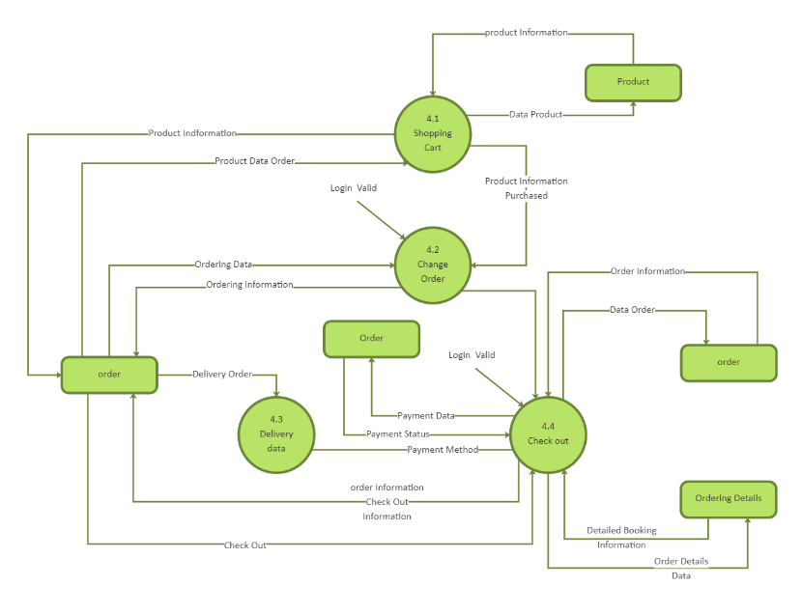
FIG NO.1
The Data Flow Diagram (DFD) represents how data flows within the system:
• User inputs such as login, search, and browsing actions
• Frontend sends requests to backend
• Backend processes logic and recommendation algorithms
• Database stores and retrieves user and product data
• Processed results are sent back to frontend
• Recommendations and product details are displayed

4.5 Use Case Diagram:
The Use Case Diagram shows how different users interact with the system.
Actors:
• User
• Administrator
Use Cases:
• Register/Login
• Browse Products
• Add to Cart
• Place Order
• View Recommendations
• Manage Products (Admin)
• View Dashboard

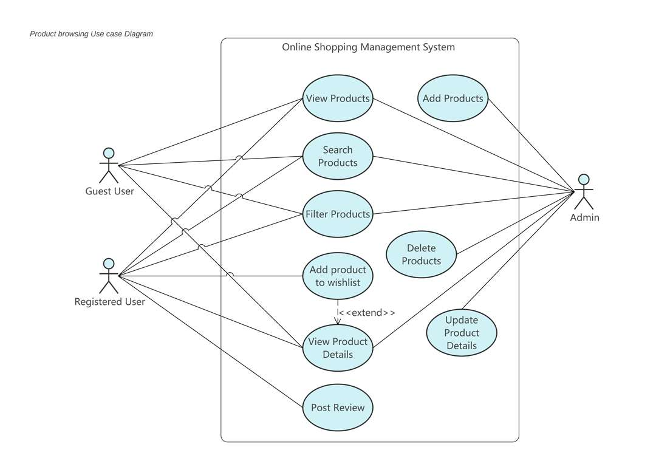
FIG NO.2
4.6 Class Diagram:
Main Classes:
• User (id, name, email, password, preferences)
• Product (id, name, category, price, description)
• Order (orderId, userId, products, totalAmount)
• Cart (userId, items)
• Recommendation (userId, suggestedProducts)

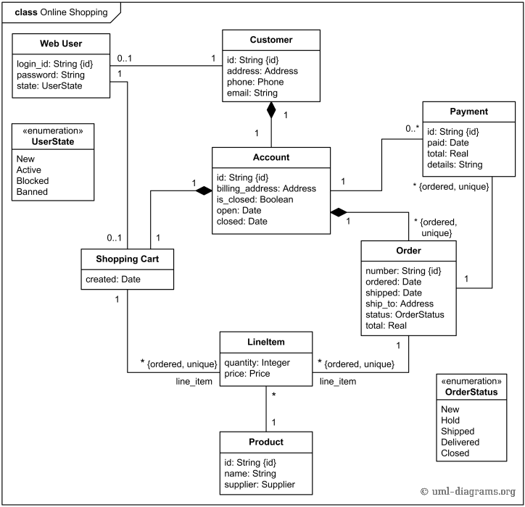
FIG NO.3

4.7 Activity Diagram:
The Activity Diagram shows system workflow.
Flow:
• User logs in
• Browses products
• System tracks activity
• Recommendation engine runs
• Products are suggested
• User adds items to cart
• Order is placed
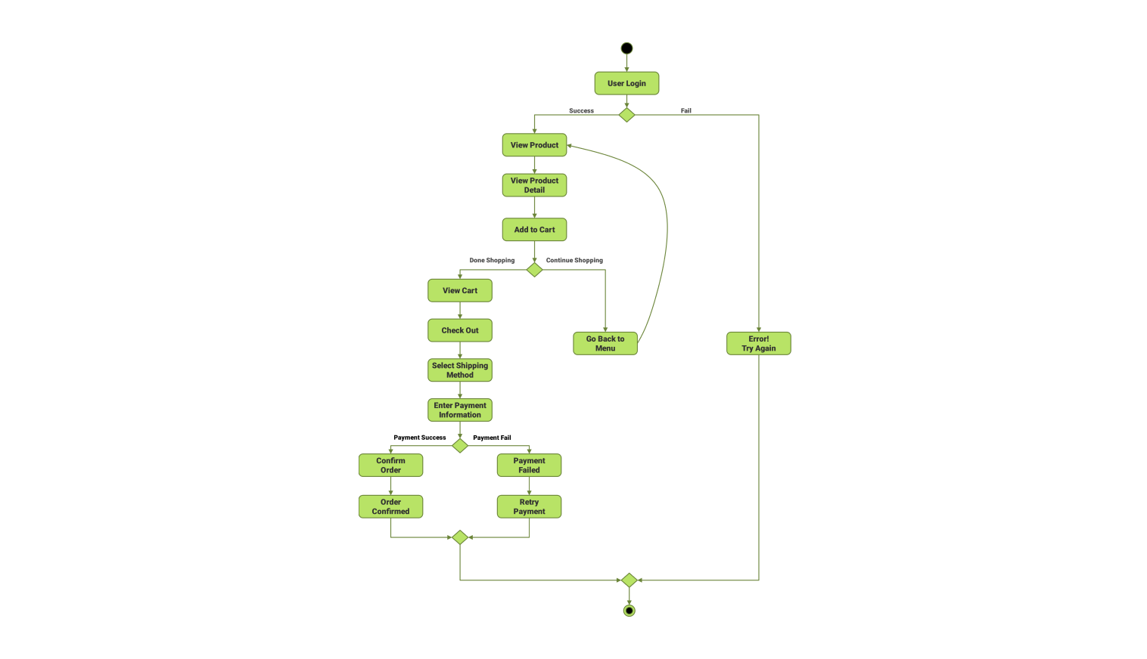
FIG NO.4

4.8 Sequence Diagram:
The Sequence Diagram represents interaction between system components over time.
Sequence Flow:
• User sends request
• Frontend calls backend API
• Backend processes logic
• Database retrieves data
• Recommendation engine runs
• Response is sent to frontend

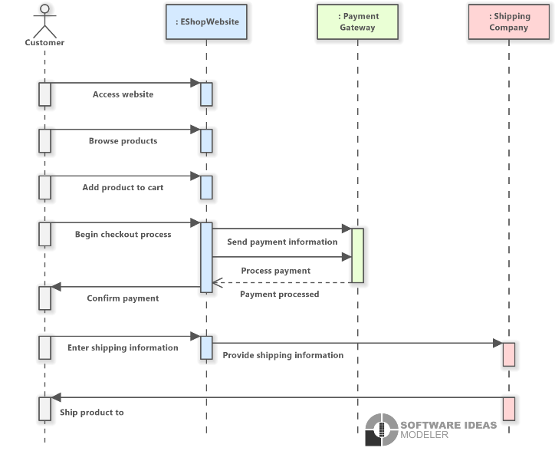
FIG NO.5

CHAPTER- 5
SYSTEM ARCHITECTURE & DESIGN
5.1 Overview
The E-Commerce Product Recommendation System is designed using a modern, scalable, and intelligent architecture that follows the principles of modularity, separation of concerns, and data-driven decision-making. The system is implemented as a full-stack web application integrating frontend, backend, and database components to provide seamless e-commerce functionality such as product browsing, cart management, order processing, and personalized product recommendations.
The architecture ensures efficient communication between system components through RESTful APIs, enabling real-time interaction between users and the system. It is designed to handle large volumes of product data and user interactions while maintaining high performance and responsiveness.
The system focuses on personalization by integrating recommendation algorithms that analyze user behavior such as browsing history, search patterns, and purchase activities. This enables the system to provide intelligent and relevant product suggestions, enhancing user experience and engagement.
Security is also an important aspect of the system design. Authentication is implemented using JWT, ensuring that only authorized users can access system functionalities. Sensitive data is protected using encryption and secure communication protocols.
The design emphasizes scalability, allowing the system to handle increasing numbers of users and products without performance degradation. It also supports modular development, making it easy to maintain, upgrade, and extend the system with new features such as advanced analytics and AI-based recommendations.

5.2 System Architecture
The system follows a three-tier architecture, which includes:
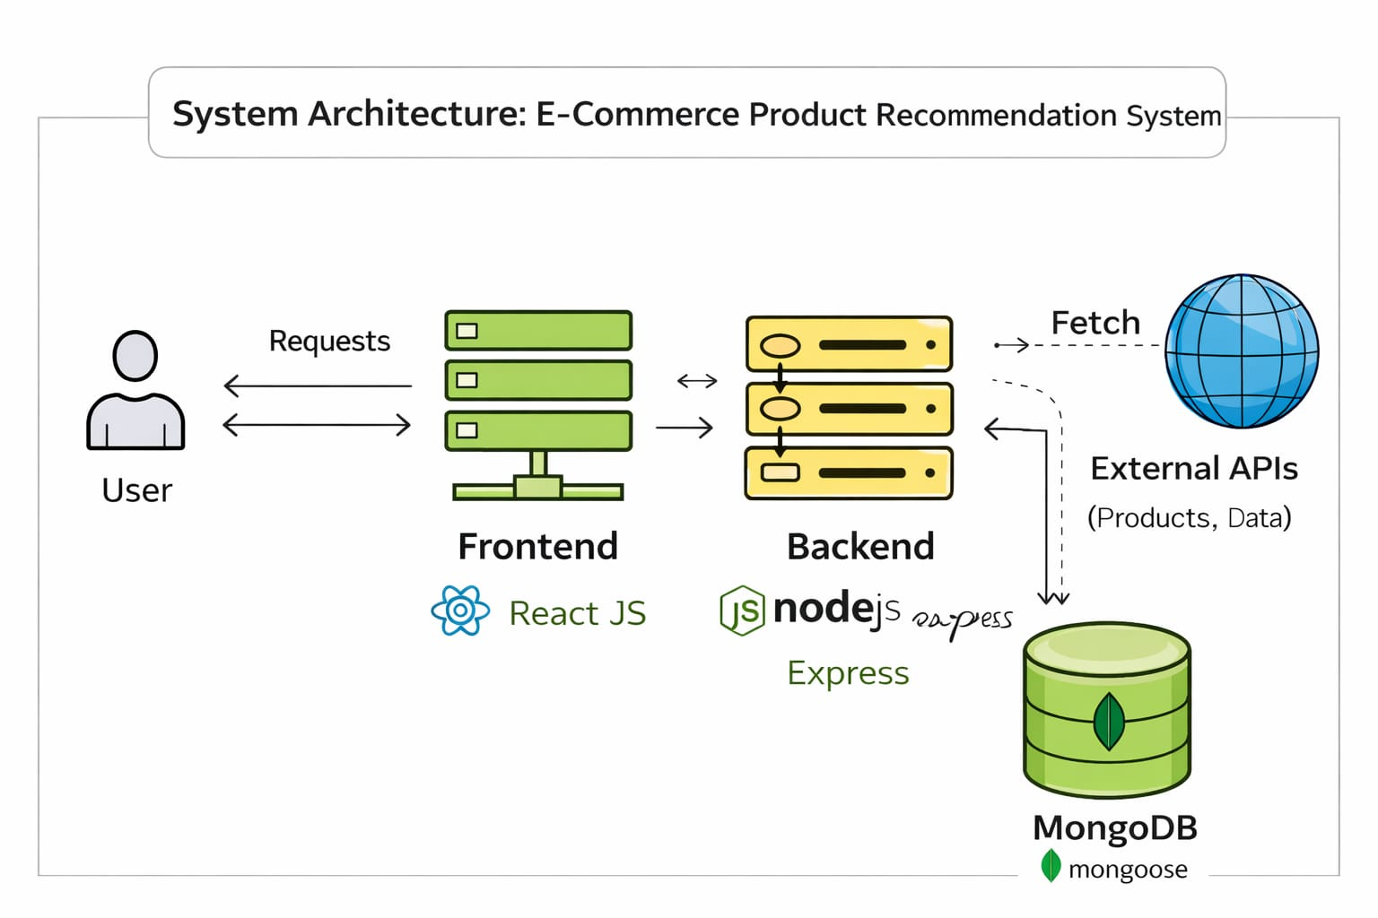
FIG NO.6

5.2.1 Presentation Layer (Frontend)
The presentation layer is responsible for user interaction and interface design. It is developed using React.js, which provides a dynamic, responsive, and interactive user experience.
Key Features:
• User registration and login interface
• Product listing and browsing interface
• Product detail pages with descriptions and images
• Personalized recommendation section
• Shopping cart interface
• Order placement and checkout page
• Search and filtering options
• Responsive design for mobile and desktop devices
The frontend communicates with the backend using REST APIs and ensures smooth user interaction.
5.2.2 Application Layer (Backend)
The application layer handles the core business logic and recommendation processing. It is developed using Node.js with Express.js.
Key Responsibilities:
• Handling API requests and responses
• Managing product data and user interactions
• Processing recommendation algorithms
• Tracking user behavior for analysis
• Managing cart and order operations
• Validating user inputs and requests
• Ensuring secure communication between components
• Logging system activities for monitoring
• Handling errors and exceptions efficiently
The backend acts as the central processing unit of the system, ensuring smooth operation and intelligent recommendations.
5.2.3 Data Layer (Database)
The data layer is implemented using MongoDB, which provides flexible and scalable data storage.
Key Functions:
• Storing user data and authentication details
• Managing product information and categories
• Storing user browsing and purchase history
• Maintaining cart and order details
• Supporting recommendation data processing
• Ensuring fast data retrieval and updates
• Handling large-scale datasets efficiently
• Maintaining relationships between users, products, and orders
The database plays a crucial role in enabling personalized recommendations by storing and analyzing user data.

5.3 System Design Approach
The system is designed using a modular and scalable approach, allowing independent development and integration of different components.
- Key Design Principles:
• Modularity: Separate modules for authentication, product management,
recommendation engine, and order processing
• Scalability: Supports large numbers of users and products
• Security: Implements JWT authentication and data protection mechanisms
• Reusability: APIs and components can be reused across modules
• Maintainability: Easy to update and modify system components
• Reliability: Ensures consistent system performance
• Flexibility: Allows integration of advanced recommendation techniques
• Performance Optimization: Efficient handling of large datasets
This design approach ensures that the system remains efficient, flexible, and easy to maintain.

5.4 Database Design
The database is designed to efficiently store and manage user, product, and recommendation data.
5.4.1 Product Collection
Stores product-related information.
Fields:
• Product ID
• Name
• Category
• Price
• Description
• Image URL
• Ratings
• Stock Quantity
5.4.2 Order Collection
Stores details of user orders.
Fields:
• Order ID
• User ID
• Product List
• Total Amount
• Order Date
• Status
5.4.3 Recommendation Collection
Stores generated recommendations.
Fields:
• User ID
• Recommended Products
• Timestamp

5.4.4 Relationships
• One user can have multiple orders
• One user interacts with multiple products
• Products are linked to categories
• Recommendations are generated based on user behavior
• Orders link users and products

5.5 API Design
The system uses RESTful APIs to enable communication between frontend and backend.
Key API Endpoints:
• GET /products → Fetch product list
• GET /product/:id → Fetch product details
• POST /cart → Add product to cart
• POST /order → Place order
• GET /orders → Fetch user orders
• GET /recommendations → Get recommended products
• POST /product → Admin adds product
• DELETE /product/:id → Admin deletes product
The APIs are designed to be secure, scalable, and efficient.

5.6 User Interface Design
The user interface is designed to be simple, intuitive, and engaging.
Key UI Components:
• Login and Registration Pages
• Product Listing Page
• Product Details Page
• Recommendation Section
• Shopping Cart Page
• Order Checkout Page
• User Dashboard
• Admin Dashboard
• Data visualization using charts
The UI enhances user experience and improves navigation efficiency.

5.7 System Workflow Design
The workflow of the system is structured as follows:
- User registers and logs into the system
- System authenticates user using JWT
- User browses products
- System tracks user activity
- Recommendation engine analyses behaviour
- System generates personalized recommendations
- User adds products to cart
- User places order
- Database updates order details
- System displays order confirmation
- User can view order history

5.8 Advantages of the Design
Personalized recommendation system
• Scalable and flexible architecture
• Efficient data handling and processing
• Secure authentication and data protection
• Improved user experience
• Real-time product suggestions
• Easy maintenance and upgrades
• High performance and responsiveness
• Increased user engagement and sales

CHAPTER- 6
IMPLEMENTATION
6.1 Overview
The implementation of the E-Commerce Product Recommendation System involves the development of a scalable, efficient, and intelligent full-stack web application that simulates real-world online shopping and recommendation functionalities. The system is implemented using modern web technologies where the frontend is developed using React.js, the backend is built using Node.js with Express.js, and MongoDB is used as the database for storing user, product, and interaction data.
The implementation focuses on core functionalities such as user authentication, product browsing, cart management, order processing, and personalized product recommendation. The recommendation engine plays a key role in analysing user behaviour and generating relevant suggestions in real time.
RESTful APIs are used for communication between frontend and backend, ensuring seamless data exchange and synchronization. The system follows a modular architecture where each component is developed independently and integrated efficiently.
Special attention is given to performance optimization, ensuring fast response times and smooth user interaction. The system also supports scalability, allowing it to handle increasing numbers of users and products. Error handling mechanisms are implemented to ensure stability and reliability.
The implementation ensures that all user activities such as browsing, searching, and purchasing are tracked and utilized for improving recommendation accuracy.

6.2 Frontend Implementation
The frontend is developed using React.js, providing a dynamic and responsive user interface. It handles user interaction, displays product data, and communicates with the backend using API calls.
Key Features:
• User registration and login forms
• Product listing and browsing interface
• Product details page
• Personalized recommendation section
• Shopping cart interface
• Order checkout page
• Search and filtering functionality
• Real-time updates using API integration
• Client-side validation and error handling
• Responsive design for multiple devices
The frontend uses Axios for API communication. React hooks such as useState and useEffect are used for state management and rendering.
Source Code (React Component):
-Main UI component handling product display.
// src/App.tsx
import React from 'react';
import { BrowserRouter as Router, Routes, Route } from 'react-router-dom';
import { CartProvider } from './hooks/useCart';
import Home from './pages/Home';
import Products from './pages/Products';
import ProductDetail from './pages/ProductDetail';
import Cart from './pages/Cart';
import About from './pages/About';
import Contact from './pages/Contact';
import Payment from './pages/payment';
import './App.css';

function App() {
return (
<CartProvider>
<Router>
<div className="App">
<Routes>
<Route path="/" element={<Home />} />
<Route path="/products" element={<Products />} />
<Route path="/product/:id" element={<ProductDetail />} />
<Route path="/cart" element={<Cart />} />
<Route path="/payment" element={<Payment />} />
<Route path="/about" element={<About />} />
<Route path="/contact" element={<Contact />} />
</Routes>
</div>
</Router>
</CartProvider>
);
}

export default App:

-Entry Point of React Application
// src/index.tsx
import React from 'react';
import ReactDOM from 'react-dom/client';
import './index.css';
import App from './App';
import reportWebVitals from './reportWebVitals';

const root = ReactDOM.createRoot(
document.getElementById('root') as HTMLElement
);
root.render(
<React.StrictMode>
<App />
</React.StrictMode>
);

// If you want to start measuring performance in your app, pass a function
// to log results (for example: reportWebVitals(console.log))
// or send to an analytics endpoint. Learn more: https://bit.ly/CRA-vitals
reportWebVitals();

HOOK LOGIC:
-Manages cart state and operations.
// src/useCart.ts
import React, { createContext, useContext, useReducer, useEffect, ReactNode } from 'react';
import { Cart, CartItem } from '../types/Product';
import { cartAPI } from '../services/api';

interface CartContextType {
cart: Cart | null;
loading: boolean;
addToCart: (productId: string, quantity: number) => Promise<void>;
updateQuantity: (productId: string, quantity: number) => Promise<void>;
removeFromCart: (productId: string) => Promise<void>;
clearCart: () => Promise<void>;
cartCount: number;
}

const CartContext = createContext<CartContextType | undefined>(undefined);

type CartAction =
| { type: 'SET_CART'; payload: Cart }
| { type: 'ADD_TO_CART'; payload: Cart }
| { type: 'UPDATE_QUANTITY'; payload: Cart }
| { type: 'REMOVE_FROM_CART'; payload: Cart }
| { type: 'CLEAR_CART'; payload: Cart }
| { type: 'SET_LOADING'; payload: boolean };

const cartReducer = (state: { cart: Cart | null; loading: boolean }, action: CartAction) => {
switch (action.type) {
case 'SET_CART':
return { ...state, cart: action.payload, loading: false };
case 'ADD_TO_CART':
case 'UPDATE_QUANTITY':
case 'REMOVE_FROM_CART':
case 'CLEAR_CART':
return { ...state, cart: action.payload, loading: false };
case 'SET_LOADING':
return { ...state, loading: action.payload };
default:
return state;
}
};

const getUserId = () => {
let userId = localStorage.getItem('userId');
if (!userId) {
userId = 'user_' + Math.random().toString(36).substr(2, 9);
localStorage.setItem('userId', userId);
}
return userId;
};

export const CartProvider: React.FC<{ children: ReactNode }> = ({ children }) => {
const [state, dispatch] = useReducer(cartReducer, { cart: null, loading: true });
const userId = getUserId();

useEffect(() => {
loadCart();
}, []);

const loadCart = async () => {
try {
dispatch({ type: 'SET_LOADING', payload: true });
const cart = await cartAPI.getCart(userId);
dispatch({ type: 'SET_CART', payload: cart });
} catch (error) {
console.error('Error loading cart:', error);
dispatch({ type: 'SET_LOADING', payload: false });
}
};

const addToCart = async (productId: string, quantity: number) => {
try {
const updatedCart = await cartAPI.addToCart(userId, productId, quantity);
dispatch({ type: 'ADD_TO_CART', payload: updatedCart });
} catch (error) {
console.error('Error adding to cart:', error);
}
};

const updateQuantity = async (productId: string, quantity: number) => {
try {
const updatedCart = await cartAPI.updateCart(userId, productId, quantity);
dispatch({ type: 'UPDATE_QUANTITY', payload: updatedCart });
} catch (error) {
console.error('Error updating cart:', error);
}
};

const removeFromCart = async (productId: string) => {
try {
const updatedCart = await cartAPI.removeFromCart(userId, productId);
dispatch({ type: 'REMOVE_FROM_CART', payload: updatedCart });
} catch (error) {
console.error('Error removing from cart:', error);
}
};

const clearCart = async () => {
try {
const clearedCart = await cartAPI.clearCart(userId);
dispatch({ type: 'CLEAR_CART', payload: clearedCart });
} catch (error) {
console.error('Error clearing cart:', error);
}
};

const cartCount = state.cart?.items.reduce((total, item) => total + item.quantity, 0) || 0;

const contextValue: CartContextType = {
cart: state.cart,
loading: state.loading,
addToCart,
updateQuantity,
removeFromCart,
clearCart,
cartCount,
};

return React.createElement(
CartContext.Provider,
{ value: contextValue },
children
);
};

export const useCart = () => {
const context = useContext(CartContext);
if (context === undefined) {
throw new Error('useCart must be used within a CartProvider');
}
return context;
};

6.3 Backend Implementation
The backend is developed using Node.js and Express.js, which handles business logic, API requests, authentication, and recommendation processing.
Key Features:
• REST API development
• Product and user management
• Recommendation engine logic
• User activity tracking
• Order processing
• Input validation and error handling
• Role-based access control

Error Handling and Validation:
The system includes robust error handling mechanisms.
• Validation is performed at frontend and backend
• Invalid inputs are rejected
• Error messages are displayed to users
• Logging is used for debugging
• System handles API failures gracefully

Source Code (Express API):
-Handles API Requests and database connection.
// src/server.ts
import express from 'express';
import mongoose from 'mongoose';
import cors from 'cors';
import dotenv from 'dotenv';
import natural from 'natural';
import productRoutes from './routes/products';
import cartRoutes from './routes/cart';
import recommendationRoutes from './routes/recommendations';
import Product from './models/Product';

dotenv.config();

const app = express();
const PORT = process.env.PORT || 5000;

// Middleware
app.use(cors());
app.use(express.json());

// Serve static files (images)
app.use(express.static('public'));

// MongoDB connection
const MONGODB_URI = process.env.MONGODB_URI || 'mongodb+srv://username_db_user:<password>@aadithya.sgm27bf.mongodb.net/ecommerce';

mongoose.connect(MONGODB_URI)
.then(() => console.log('Connected to MongoDB'))
.catch((error) => console.error('MongoDB connection error:', error));

// Routes
app.use('/api/products', productRoutes);
app.use('/api/cart', cartRoutes);
app.use('/api/recommendations', recommendationRoutes);

// Sample data seeding
const seedSampleData = async () => {
try {
// Automatically checks and adds new products every time server starts!
const sampleProducts = [
{
name: 'Laptop Pro Max',
description: 'High-performance laptop with 16GB RAM, 512GB SSD, and latest generation processor. Perfect for professionals and content creators.',
price: 1299.99,
category: 'electronics',
image: 'http://localhost:5000/images/Laptop Pro Max.jpg',
featured: true,
rating: 4.8,
reviews: 156
},
{
name: 'Smartphone X Pro',
description: 'Flagship smartphone with 5G connectivity, triple camera system, and all-day battery life. Capture stunning photos and videos.',
price: 899.99,
category: 'electronics',
image: 'http://localhost:5000/images/Smartphone X Pro.jpg',
featured: true,
rating: 4.7,
reviews: 412
},
{
name: 'Smart TV 4K UHD',
description: '55-inch 4K Ultra HD Smart TV with HDR, built-in streaming apps, and voice control. Transform your living room into a home theater.',
price: 699.99,
category: 'electronics',
image: 'http://localhost:5000/images/Smart TV 4K UHD.jpeg',
featured: false,
rating: 4.5,
reviews: 89
},
{
name: "Men's Casual Button Down Shirt",
description: 'Premium cotton button-down shirt with modern fit and classic styling. Perfect for business casual or weekend outings.',
price: 59.99,
category: 'clothing',
image: 'http://localhost:5000/images/Men\'s Casual Button Down Shirt.jpg',
featured: true,
rating: 4.4,
reviews: 127
},
{
name: "Slim Fit Jeans",
description: 'Modern slim-fit jeans with premium denim fabric and comfortable stretch. Classic five-pocket design with contemporary styling.',
price: 79.99,
category: 'clothing',
image: 'http://localhost:5000/images/Slim Fit Jeans.jpg',
featured: false,
rating: 4.3,
reviews: 198
},
{
name: "Women's Cocktail Dress",
description: 'Elegant cocktail dress with flattering silhouette and premium fabric. Perfect for special occasions and evening events.',
price: 129.99,
category: 'clothing',
image: 'http://localhost:5000/images/Women\'s Cocktail Dress.jpg',
featured: true,
rating: 4.6,
reviews: 73
},
{
name: 'Athletic Running Shoes',
description: 'High-performance running shoes with advanced cushioning technology and breathable mesh upper. Ideal for serious runners.',
price: 119.99,
category: 'clothing',
image: 'http://localhost:5000/images/Athletic Running Shoes.jpeg',
featured: false,
rating: 4.5,
reviews: 245
},
{
name: 'High-Power Blender',
description: 'Professional-grade blender with 1500W motor and multiple speed settings. Perfect for smoothies, soups, and food processing.',
price: 199.99,
category: 'home',
image: 'http://localhost:5000/images/High-Power Blender.jpg',
featured: true,
rating: 4.7,
reviews: 189
},
{
name: 'Non-Stick Cookware Set',
description: 'Complete 10-piece cookware set with PFOA-free non-stick coating. Includes essential pots and pans for every kitchen.',
price: 149.99,
category: 'home',
image: 'http://localhost:5000/images/Non-Stick Cookware Set.jpg',
featured: false,
rating: 4.4,
reviews: 267
},
{
name: 'Programmable Coffee Maker',
description: 'Programmable coffee maker with thermal carafe and customizable brewing settings. Wake up to perfectly brewed coffee every morning.',
price: 89.99,
category: 'home',
image: 'http://localhost:5000/images/Programmable Coffee Maker.jpg',
featured: false,
rating: 4.3,
reviews: 156
},
{
name: 'Smart Toaster',
description: 'Smart toaster with precise browning control and multiple functions. Features bagel setting and automatic shut-off for perfect results.',
price: 49.99,
category: 'home',
image: 'http://localhost:5000/images/Smart Toaster.jpg',
featured: false,
rating: 4.2,
reviews: 98
},
{
name: 'Anti-Aging Moisturizer',
description: 'Advanced anti-aging moisturizer with retinol and hyaluronic acid. Reduces fine lines and wrinkles while hydrating skin.',
price: 69.99,
category: 'beauty',
image: 'http://localhost:5000/images/Anti-Aging Moisturizer.jpg',
featured: true,
rating: 4.6,
reviews: 312
},
{
name: 'Gentle Facial Cleanser',
description: 'Soft and gentle facial cleanser suitable for all skin types. Removes impurities without stripping natural oils.',
price: 34.99,
category: 'beauty',
image: 'http://localhost:5000/images/Gentle Facial Cleanser.jpg',
featured: false,
rating: 4.4,
reviews: 178
},
{
name: 'Professional Makeup Brush Set',
description: 'Complete 24-piece professional makeup brush set with premium synthetic bristles. Includes all essential brushes for flawless application.',
price: 89.99,
category: 'beauty',
image: 'http://localhost:5000/images/Professional Makeup Brush Set.jpg',
featured: true,
rating: 4.8,
reviews: 423
},
{
name: 'Luxury Perfume Collection',
description: 'Exclusive luxury perfume collection with premium fragrances. Long-lasting scents with sophisticated notes for any occasion.',
price: 159.99,
category: 'beauty',
image: 'http://localhost:5000/images/Luxury Perfume Collection.jpeg',
featured: false,
rating: 4.7,
reviews: 134
},
{
name: 'Wireless Noise-Cancelling Headphones',
description: 'Premium wireless headphones with advanced noise-cancellation technology, 40-hour battery life, and superior sound quality for immersive audio experience.',
price: 299.99,
category: 'electronics',
image: 'http://localhost:5000/images/Wireless Noise-Cancelling Headphones.jpg',
featured: true,
rating: 4.6,
reviews: 234
}
];

// Look for new products in the list above to add them smoothly without duplicates!
let addedAnything = false;
for (const item of sampleProducts) {
const alreadyExists = await Product.findOne({ name: item.name });
if (!alreadyExists) {
await Product.create(item);
console.log(`Auto-added new item: ${item.name}`);
addedAnything = true;
}
}
if (addedAnything) console.log('Successfully synced new items to backend!');
} catch (error) {
console.error('Error seeding data:', error);
}
};

// Start server
app.listen(PORT, () => {
console.log(`Server running on port ${PORT}`);
seedSampleData();
});

6.4 Dependencies :
-Contains backend libraries like Express and database collection
//backend/pakage.json
{
"name": "backend",
"version": "1.0.0",
"description": "",
"main": "dist/server.js",
"scripts": {
"start": "node dist/server.js",
"dev": "nodemon src/server.ts",
"build": "tsc",
"test": "echo \"Error: no test specified\" && exit 1"
},
"keywords": [],
"author": "",
"license": "ISC",
"type": "commonjs",
"dependencies": {
"cors": "^2.8.6",
"dotenv": "^17.4.0",
"express": "^5.2.1",
"mongoose": "^9.4.1",
"natural": "^8.1.1"
},
"devDependencies": {
"@types/cors": "^2.8.19",
"@types/express": "^5.0.6",
"@types/node": "^25.5.2",
"nodemon": "^3.1.14",
"ts-node": "^10.9.2",
"typescript": "^6.0.2"
}
}

-Contains frontend libraries like React and UI dependencies
//frontend/package.json
{
"name": "frontend",
"version": "0.1.0",
"private": true,
"dependencies": {
"@testing-library/dom": "^10.4.1",
"@testing-library/jest-dom": "^6.9.1",
"@testing-library/react": "^16.3.2",
"@testing-library/user-event": "^13.5.0",
"@types/jest": "^27.5.2",
"@types/node": "^16.18.126",
"@types/react": "^19.2.14",
"@types/react-dom": "^19.2.3",
"axios": "^1.14.0",
"react": "^19.2.4",
"react-dom": "^19.2.4",
"react-router-dom": "^7.14.0",
"react-scripts": "5.0.1",
"typescript": "^4.9.5",
"web-vitals": "^2.1.4"
},
"scripts": {
"start": "react-scripts start",
"build": "react-scripts build",
"test": "react-scripts test",
"eject": "react-scripts eject"
},
"eslintConfig": {
"extends": [
"react-app",
"react-app/jest"
]
},
"browserslist": {
"production": [
">0.2%",
"not dead",
"not op_mini all"
],
"development": [
"last 1 chrome version",
"last 1 firefox version",
"last 1 safari version"
]
}
}

6.5 Environment :
-Stores configuration variables
//backend/.env
MONGODB_URI=mongodb+srv://username_db_user:<password>@aadithya.sgm27bf.mongodb.net/ecommerce
PORT=5000

6.6 Database Implementation
MongoDB is used for storing user data, product information, and recommendation-related data. Mongoose is used for schema definition and database interaction.
Key Features:
• Flexible NoSQL database
• Scalable data storage
• Fast retrieval of user and product data
• Schema-based validation
• Efficient handling of large datasets
Sample Schema (Mongoose):
// models/Product.js
const mongoose = require("mongoose");
const productSchema = new mongoose.Schema({
name: String,
category: String,
price: Number,
description: String,
});
module.exports = mongoose.model("Product", productSchema);

6.7 Recommendation Engine Implementation
The recommendation engine is a core component of the system. It analyzes user behavior and generates personalized product suggestions.
Key Implementation Steps:
• Track user browsing and purchase history
• Store interaction data in database
• Apply content-based filtering
• Apply collaborative filtering
• Combine results using hybrid approach
• Rank products based on relevance
• Display recommendations to users
The system continuously improves recommendations based on user interactions.

6.8 Performance Optimization
The system is optimized for performance using:
• Efficient API design
• Database indexing
• Minimized data transfer
• Caching techniques (optional)
• Optimized rendering in frontend
• Load handling for multiple users
The system ensures fast response times and smooth user experience

CHAPTER- 7
TESTING
7.1 Overview
Testing is a critical phase in the software development life cycle that ensures the E-Commerce Product Recommendation System operates correctly, efficiently, and securely under various conditions. The primary objective of testing is to identify and eliminate errors, validate system functionality, and ensure that the application meets both functional and non-functional requirements. Since the system handles user data, product information, and recommendation logic, testing plays a vital role in ensuring accuracy, reliability, and performance.
The system is tested at multiple levels to verify each module independently as well as the system as a whole. Modules such as user authentication, product browsing, recommendation engine, cart management, and order processing are tested thoroughly to ensure correct functionality. Testing also ensures that the system can handle multiple users simultaneously without performance degradation.
Testing also focuses on data integrity, ensuring that user activity data, product data, and order details are stored and retrieved correctly. Security testing is performed to protect user information and prevent unauthorized access.
Additionally, usability testing ensures that the interface is simple, intuitive, and easy to navigate. Error handling mechanisms are tested to provide meaningful feedback in case of invalid inputs or failures. Overall, testing ensures that the system is robust, scalable, and ready for real-world deployment.

7.2 Objectives of Testing
The main objectives of testing in the E-Commerce Product Recommendation System are:
• To verify that all functional requirements are implemented correctly
• To ensure accurate product recommendation generation
• To validate user data and product data consistency
• To identify and fix bugs or system errors
• To ensure secure authentication and authorization
• To evaluate system performance under different conditions
• To ensure smooth user interaction and navigation
7.3 Types of Testing
The E-Commerce Product Recommendation System undergoes multiple types of testing to ensure high quality and reliability.
7.3.1 Unit Testing
Unit testing involves testing individual components independently.
In this project:
• Testing login and registration modules
• Testing product fetching functionality
• Testing recommendation logic
• Testing cart operations
• Testing order processing functions
Purpose:
To ensure each component works correctly in isolation.
7.3.2 Integration Testing
Integration testing verifies interaction between modules.
In this project:
• Frontend communicating with backend APIs
• Backend interacting with MongoDB
• Recommendation engine integrated with user data
• Cart module interacting with product database
• Order system updating correctly
Purpose:
To ensure proper communication and data flow.
7.3.3 System Testing
System testing evaluates the entire system.
In this project:
• End-to-end workflow (Login → Browse → Recommend → Add to Cart → Order)
• Full system navigation testing
• Admin and user operations testing
Purpose:
To ensure system works as expected in real scenarios.
7.3.5 Functional Testing
Functional testing ensures all features work correctly.
In this project:
• User authentication
• Product browsing and search
• Recommendation system
• Cart and order functionality
• Dashboard features
Purpose:
To validate system functionalities.
7.3.6 Non-Functional Testing
a) Performance Testing
• Measures system response time
• Evaluates handling of multiple users
• Ensures fast recommendation generation
• Tests system under load
b) Security Testing
• Verifies JWT authentication
• Prevents unauthorized access
• Protects user data
• Ensures secure API communication
c) Usability Testing
• Evaluates user interface
• Ensures easy navigation
• Tests user interaction experience
7.3.8 API Testing
API testing validates backend endpoints.
In this project:
• Testing /products API
• Testing /recommendations API
• Testing /cart API
• Testing /order API
Purpose:
To ensure correct responses and performance.

7.4 Testing Tools Used
• Postman for API testing
• Browser Developer Tools for debugging
• Console logs for error tracking
• MongoDB Compass for database testing
• Network tools for monitoring API calls

7.5 Performance Analysis
The system demonstrates strong performance:
• Fast response time for API requests
• Efficient recommendation generation
• Handles multiple users simultaneously
• Minimal latency in data retrieval
• Stable performance under normal usage
Load testing shows the system can handle multiple users without failure.

7.6 Results of Testing
The testing process confirms that the system functions correctly and meets all requirements. The system demonstrates:
• Accurate product recommendations
• Secure authentication
• Smooth user interaction
• High reliability and stability
• Efficient performance

CHAPTER- 8
EXPERIMENTS & RESULTS
8.1 Overview
This chapter presents the experimental results of the E-Commerce Product Recommendation System. The system was developed and tested under various real-time scenarios to evaluate its functionality, performance, accuracy, scalability, and usability. The experiments are focused on validating the core features of the system such as user registration, login authentication, product browsing, recommendation engine, cart management, and order processing. Each module is tested thoroughly to ensure that it performs correctly and efficiently under different operating conditions.
results are demonstrated using user interface screenshots along with detailed explanations, enabling a clear understanding of how the system behaves in real-world scenarios. The experiments also evaluate the effectiveness of the recommendation engine in suggesting relevant products based on user behaviour such as browsing history, search patterns, and purchase activity.
Additionally, the system is tested for its ability to handle multiple users simultaneously without affecting performance. The experiments validate that the system maintains data consistency, prevents errors, and provides accurate outputs even under concurrent usage. The overall results confirm that the system is robust, reliable, and suitable for real-world e-commerce applications.

8.2 Experimental Setup
The E-Commerce Product Recommendation System was developed and tested using a modern full-stack web development environment. The frontend is implemented using React.js, providing an interactive and responsive user interface. The backend is developed using Node.js with Express.js, which handles API requests, business logic, and recommendation processing. MongoDB is used as the database to store user data, product information, and user interaction history.
Testing tools such as Postman are used to validate API endpoints and ensure correct backend functionality. Browser developer tools are used to debug frontend components and monitor network requests. The system is tested using web browsers such as Google Chrome to ensure compatibility and performance across different environments.
The experiments are conducted on a system with standard hardware configuration, including sufficient RAM and processing capability, along with a stable internet connection. Environment variables are properly configured to ensure secure API communication and database connectivity.
Different test scenarios are executed, including normal usage, edge cases, and error conditions. The system is also tested with multiple users to evaluate scalability and performance. The experimental setup ensures that the system is tested in conditions similar to real-world e-commerce platforms.

8.3 Module-wise Results

1. Backend Terminal Running
Description:
Backend server running successfully with MongoDB connection established
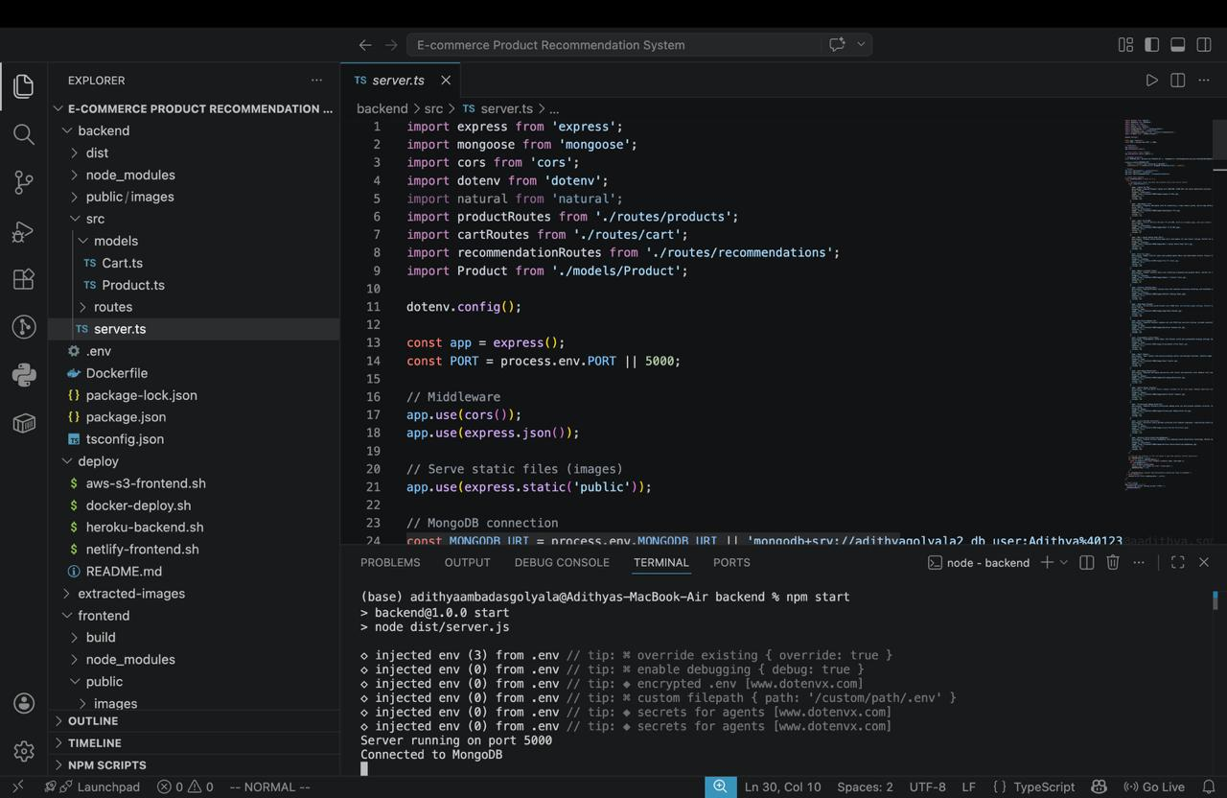

2. Frontend Terminal Running
Description:
Frontend React application compiled and running using npm start.
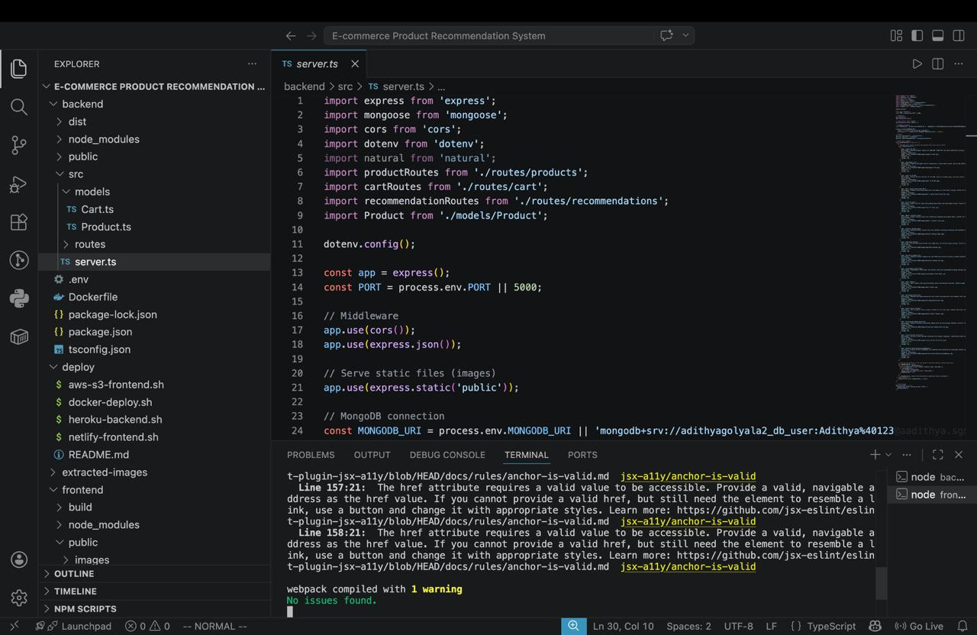

3. Home Page(Welcome Screen)
Description:
Home page displaying welcome section and product categories.
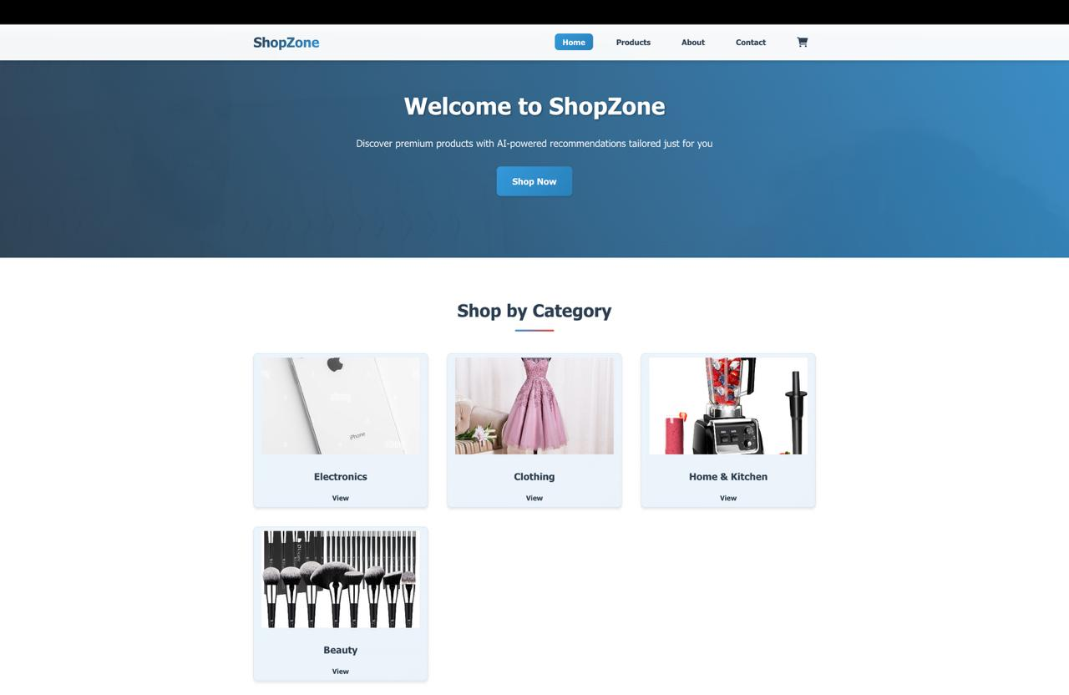

4. Products Page
Description:
Products page showing available items with search and filter options.
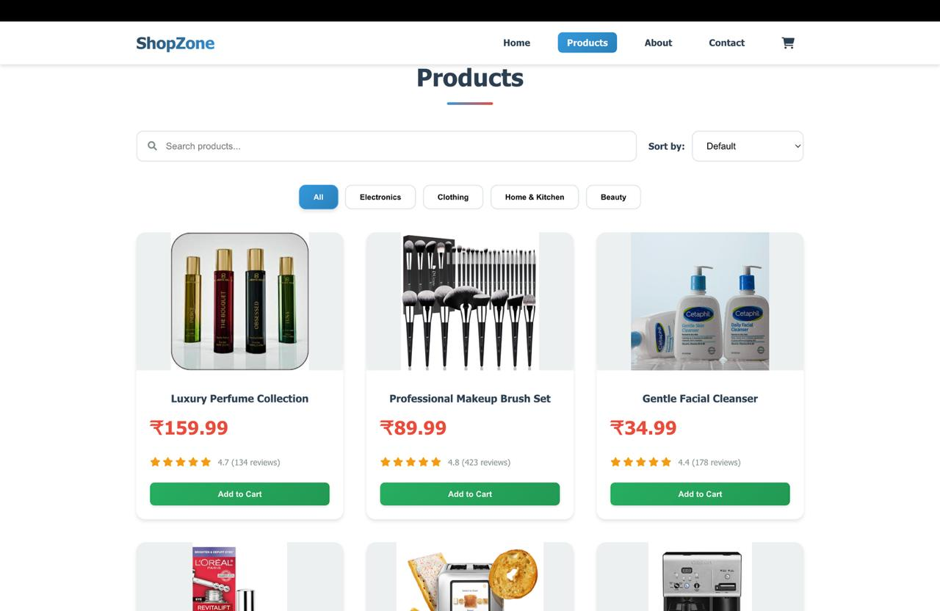

5. Featured Products
Description:
Featured products section highlighting selected items.
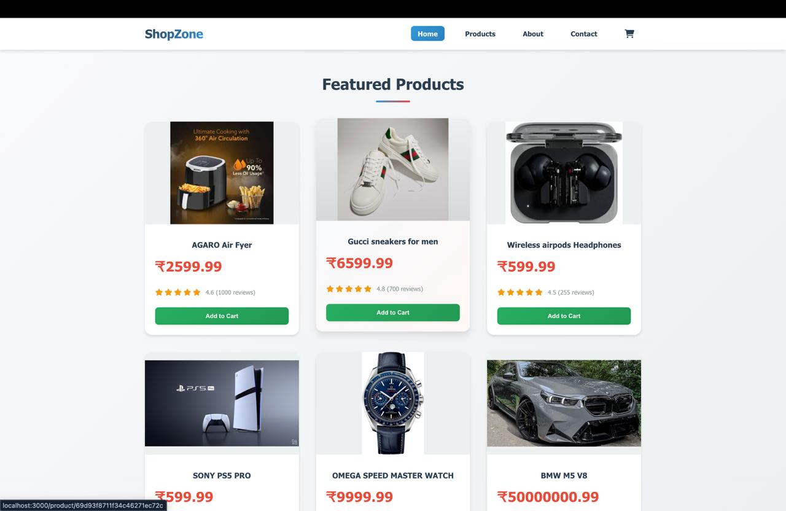

6. Recommended Products
Description:
Recommendation system displaying personalized product suggestions.
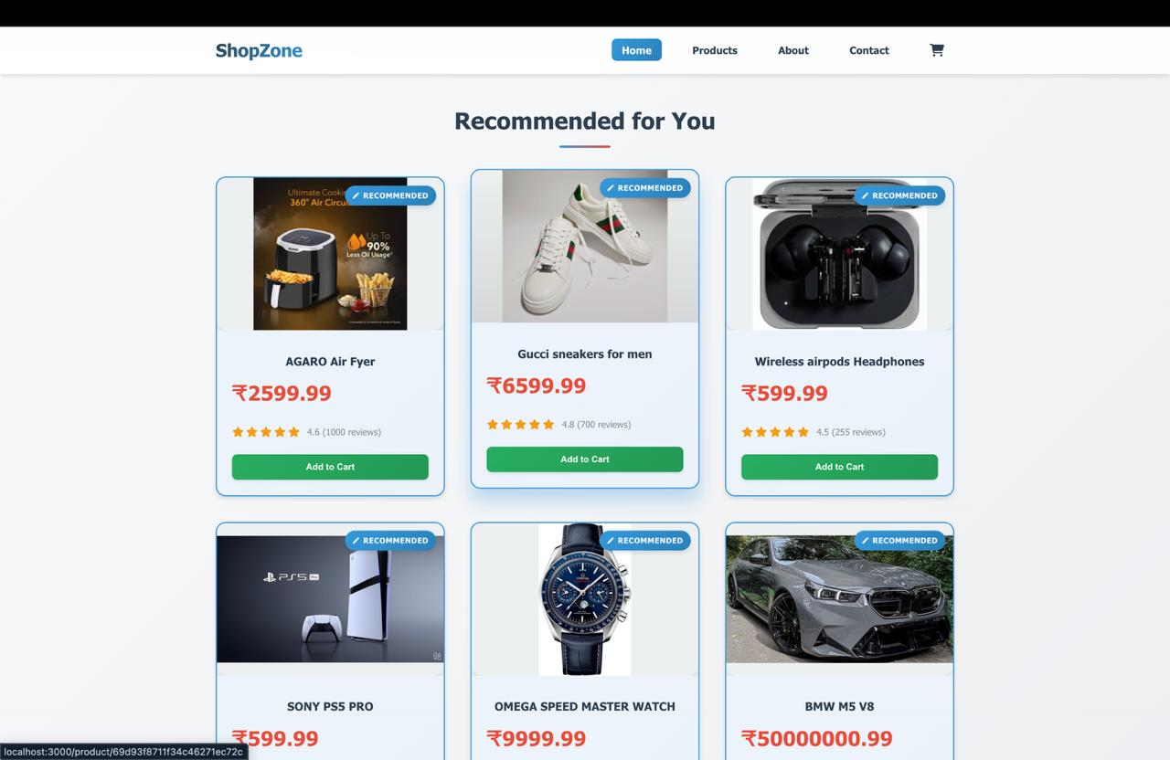

7. Cart Page (Items Added)
Description:
Shopping cart page displaying selected items and total amount.
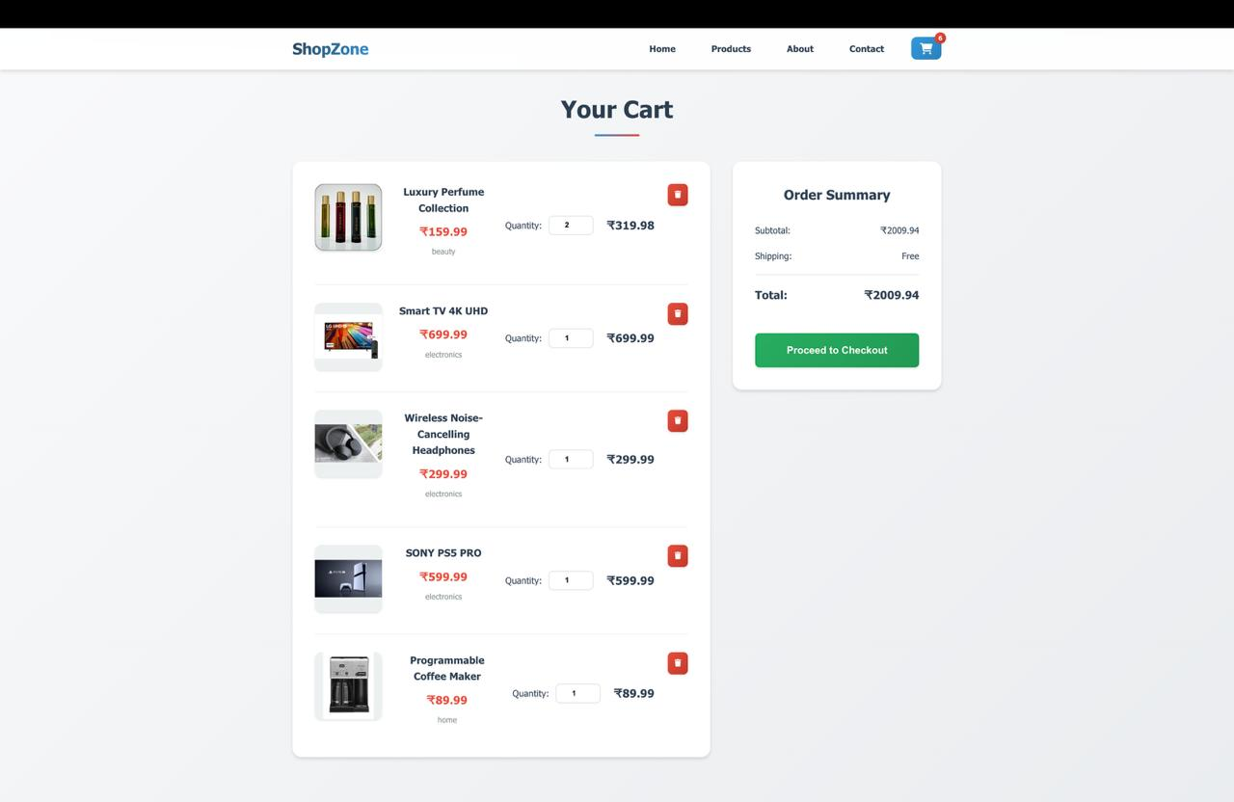

8. Payment Flow
Description:
The following figures illustrate the payment process of the system including QR payment,UPI payment,Card Payment,Processing And Success Screen.

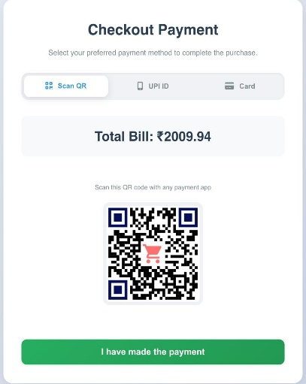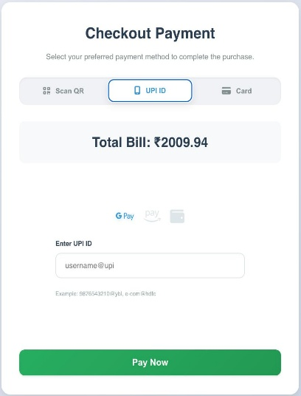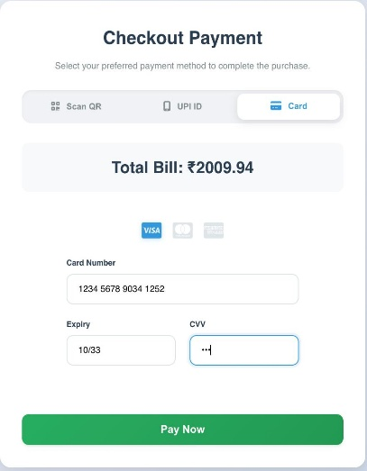
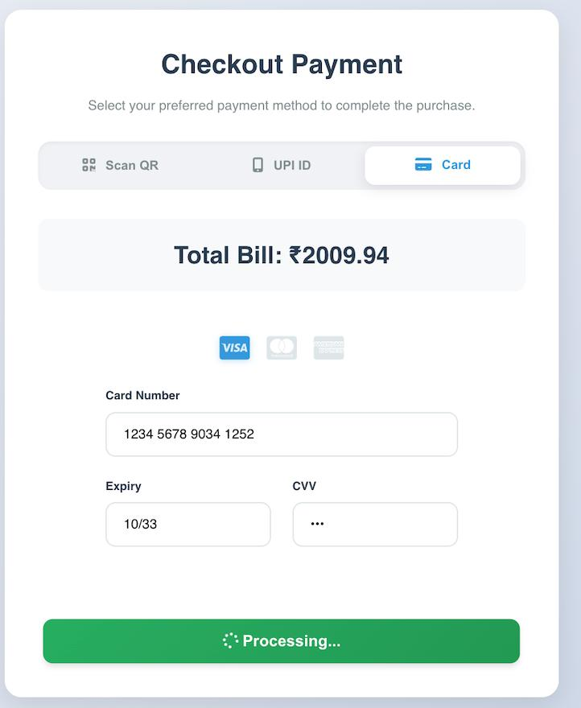

Success Screen
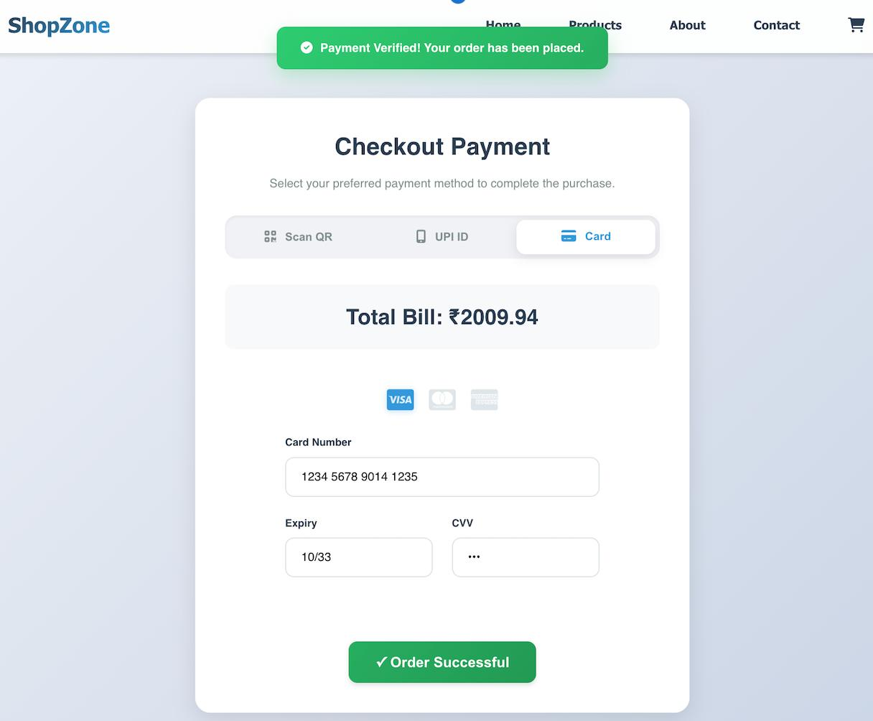

9. About & Contact Page
Description:
About page providing information about the platform and services and Contact page allowing users to send queries and view contact details.

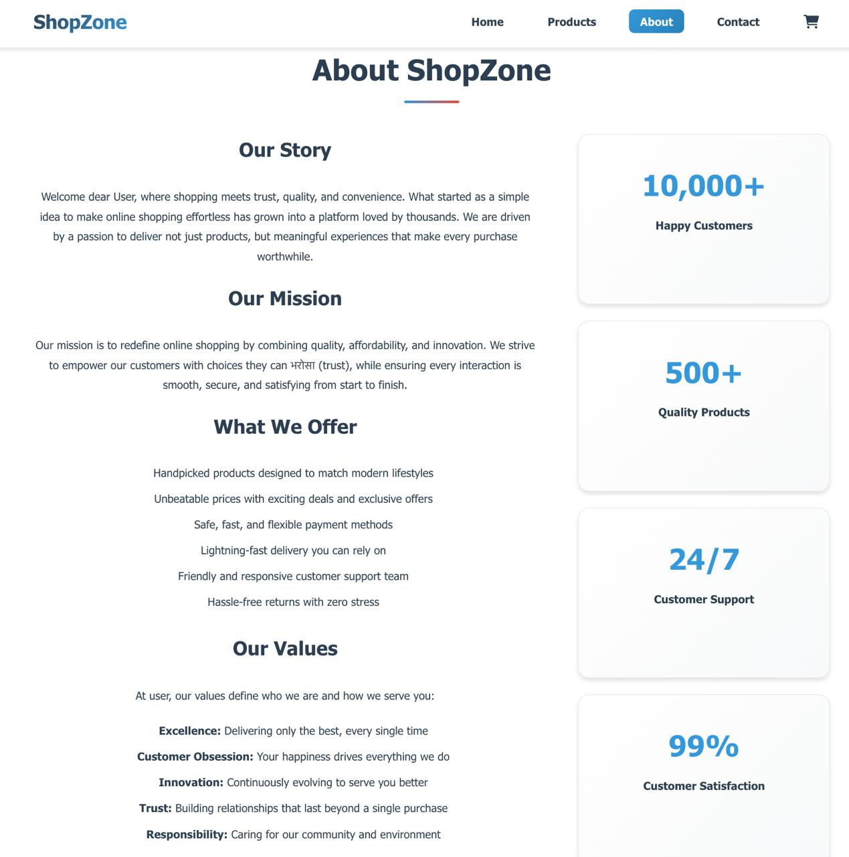
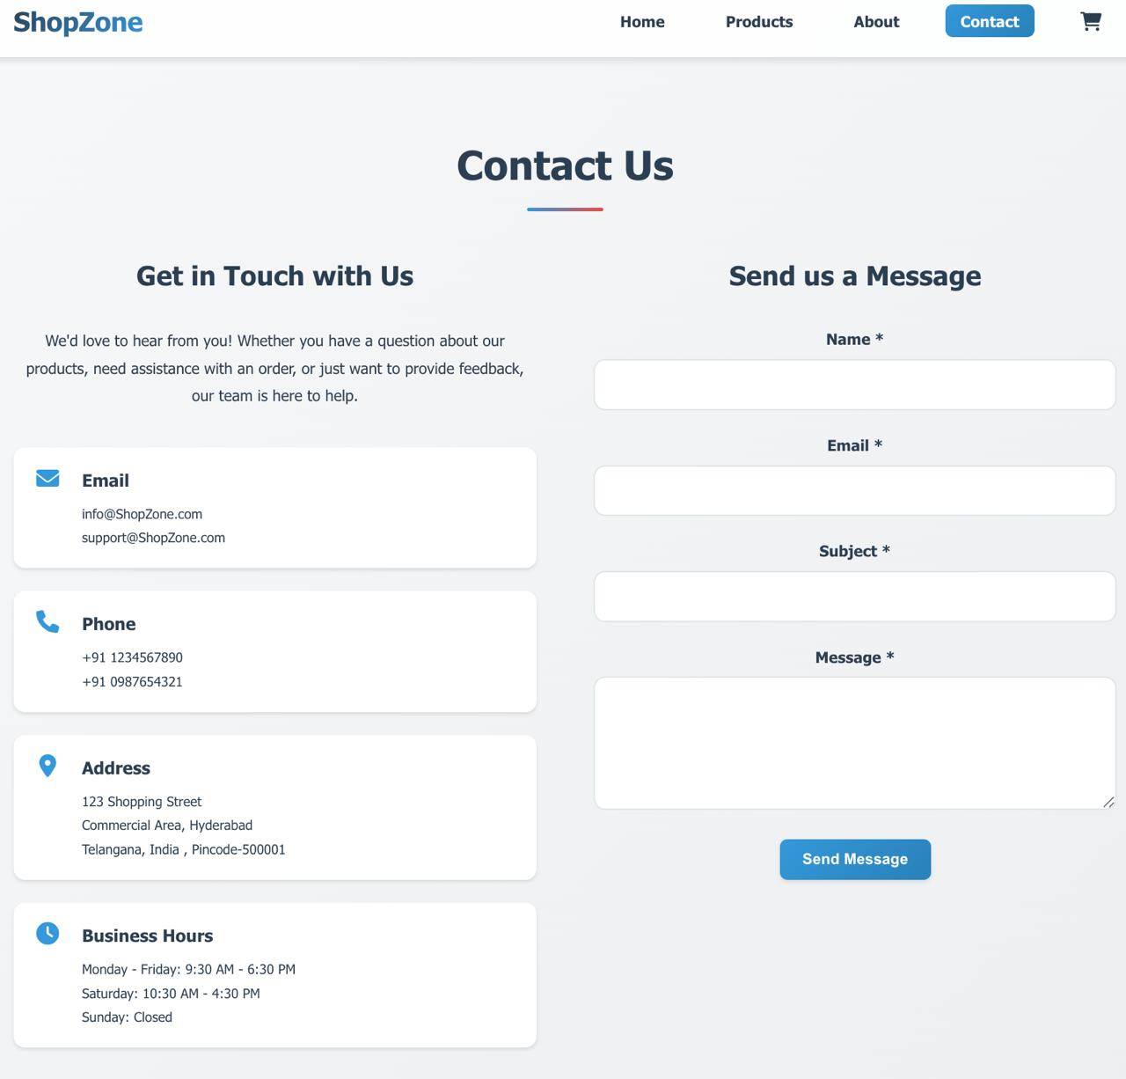

8.4 Performance Analysis
The system demonstrates strong performance in terms of speed, accuracy, and scalability. API response times are minimal, ensuring fast data retrieval. The recommendation engine processes data quickly and provides real-time suggestions. The system can handle multiple users simultaneously without performance degradation.
Database queries are optimized using indexing and efficient schema design. Frontend rendering is optimized to reduce load time. Load testing shows that the system remains stable under multiple user requests. Overall, the system delivers a smooth and efficient user experience.

8.5 Result Analysis
The experimental results confirm that the E-Commerce Product Recommendation System meets both functional and non-functional requirements. All modules perform correctly and efficiently. The recommendation system provides accurate results, improving user engagement.
The authentication system ensures security, while the database maintains data consistency. The user interface is simple and intuitive, making it easy for users to interact with the system. The system demonstrates high reliability, scalability, and performance.

8.6 Advantages Observed
The experiments highlight several advantages:
• Personalized product recommendations
• Fast and efficient system performance
• Secure authentication and data handling
• Improved user experience
• Real-time updates and responses
• Scalable architecture
• Reduced manual effort

CHAPTER- 9
FUTURE WORK & EXTENSIONS
9.1 Overview
The E-Commerce Product Recommendation System provides a strong foundation for enhancing online shopping experiences through personalized product suggestions, efficient product management, and seamless user interaction. However, with the rapid advancement of technology and increasing expectations from users in modern digital marketplaces, there are numerous opportunities to enhance and extend the system further.
This chapter discusses potential future improvements and extensions that can make the system more intelligent, scalable, secure, and suitable for large-scale real-world e-commerce applications. While the current system successfully implements core functionalities such as user authentication, product browsing, recommendation generation, cart management, and order processing, future enhancements can significantly improve recommendation accuracy, user engagement, and system performance.
The system can be extended by integrating advanced technologies such as Artificial Intelligence, Machine Learning, Big Data analytics, and Cloud Computing. These technologies can enable the system to provide highly personalized and predictive recommendations. Additionally, improvements in user interface design, system responsiveness, and accessibility can further enhance the user experience.
Future work also focuses on improving scalability to handle millions of users and products. With proper enhancements, the system can evolve into a complete intelligent e-commerce platform capable of competing with modern industry-level applications.

9.2 Advanced Recommendation Algorithms
One of the most important improvements is enhancing the recommendation engine using advanced algorithms.
Future enhancements may include:
• Deep Learning-based recommendation models
• Hybrid recommendation systems combining multiple techniques
• Context-aware recommendations based on time, location, and behaviour
• Real-time recommendation updates using streaming data
• Predictive recommendation using user intent analysis
• Personalized ranking algorithms
• AI-driven recommendation optimization
These improvements will significantly increase recommendation accuracy and user satisfaction.

9.3 AI-Based Personalization
Artificial Intelligence can be used to provide deeper personalization.
• Analyse user browsing patterns
• Track user preferences and interests
• Predict future purchases
• Recommend trending and personalized products
• Provide smart suggestions during search
• Implement dynamic pricing strategies
AI integration will make the system more intelligent and adaptive to user needs.

9.4 Real-Time Recommendation System
Future versions can include real-time recommendation processing.
• Use streaming technologies for live data processing
• Update recommendations instantly based on user actions
• Display live trending products
• Provide instant suggestions during browsing
• Improve responsiveness and engagement
This will enhance user experience and increase conversion rates.

9.5 Mobile Application Development
Currently, the system is web-based. Developing mobile applications can improve accessibility and engagement.
• Develop Android and iOS applications
• Provide seamless mobile shopping experience
• Enable push notifications for offers and recommendations
• Provide real-time alerts for orders
• Improve user engagement through mobile features
Mobile integration will expand the reach of the platform.

9.6 Advanced Security Features
Security can be enhanced using advanced mechanisms.
• Multi-Factor Authentication (MFA)
• Biometric authentication (fingerprint, face recognition)
• End-to-end encryption for user data
• Secure payment gateway integration
• Fraud detection mechanisms
• Role-based access control improvements
• Session management and monitoring
These features will ensure secure transactions and data protection.

9.7 Payment Gateway Integration
Future enhancements can include integration with payment systems.
• Integration with Razorpay, Stripe, PayPal
• Secure online payment processing
• Support for multiple payment methods
• Real-time transaction confirmation
• Order tracking and payment status
This will make the system fully functional for real-world e-commerce.

9.8 Cloud Scalability Enhancements
The system can be enhanced using cloud-based technologies.
• Use of microservices architecture
• Load balancing for handling high traffic
• Auto-scaling based on demand
• Distributed databases for better performance
• Cloud monitoring tools
• High availability and fault tolerance
These improvements will ensure scalability for large user bases.
9.9 Big Data Analytics Integration
Big Data technologies can be used to analyse large datasets.
• Analyse user behaviour patterns
• Track product popularity trends
• Generate insights for business decisions
• Improve recommendation accuracy
• Use data-driven decision-making
This will help businesses optimize sales strategies.

9.10 Chatbot and Voice Assistant Integration
Future systems can include intelligent assistants.
• AI chatbot for customer support
• Voice-based product search
• Conversational shopping experience
• Automated query handling
• 24/7 customer assistance
This will improve customer engagement and support.

9.11 Social Media Integration
The system can be integrated with social platforms.
• Login using social media accounts
• Share products on social platforms
• Analyse social behaviour for recommendations
• Influencer-based product suggestions
This enhances user reach and engagement.

9.12 Analytics Dashboard Enhancements
Advanced dashboards can be implemented.
• Real-time analytics for admins
• Sales and revenue reports
• User activity tracking
• Recommendation performance analysis
• Data visualization using charts
This helps in better decision-making.

9.13 Internationalization and Localization
The system can support global users.
• Multi-language support
• Currency conversion features
• Region-based product recommendations
• Local payment methods
• Localization of UI elements
This will make the system globally accessible.

9.14 Additional Future Enhancements
Further improvements can include:
• Wishlist and favourite products feature
• Product review and rating system
• Inventory management system
• Email and SMS notifications
• Recommendation based on seasonal trends
• Gamification features for users
• Loyalty and reward programs
• Augmented Reality (AR) product visualization
• Integration with IoT devices
• Automated marketing campaigns
These enhancements will transform the system into a complete intelligent e-commerce platform.

CHAPTER- 10
CONCLUSION
12.1 Overview
The E-Commerce Product Recommendation System was developed to address the challenges faced in traditional online shopping platforms, such as lack of personalization, inefficient product discovery, and limited user engagement. In many existing systems, users are required to manually search and browse through large numbers of products, which can be time-consuming and often leads to poor user experience. This project successfully demonstrates how modern web technologies and intelligent recommendation techniques can be utilized to build a smart, efficient, and scalable e-commerce solution.
The system provides a platform where users can explore products, receive personalized recommendations, add items to their cart, and place orders in a seamless and user-friendly environment. The integration of a recommendation engine significantly improves product discovery and enhances user satisfaction. The project highlights the importance of personalization in modern digital platforms, where users expect relevant and intelligent suggestions based on their interests and behaviour.
By leveraging technologies such as React.js, Node.js, Express.js, and MongoDB, the system ensures efficient data handling, real-time processing, and smooth user interaction. The project demonstrates how full-stack development can be applied to solve real-world problems in the e-commerce domain.

12.2 Summary of Work
The system was designed and implemented using a full-stack development approach, integrating React.js for the frontend, Node.js with Express.js for backend services, and MongoDB for database management. The application includes key functionalities such as user authentication, product browsing, recommendation generation, cart management, and order processing.
During the development process, multiple modules were carefully designed, implemented, and tested to ensure that the system meets both functional and non-functional requirements. The recommendation engine was developed to analyse user behaviour and provide personalized suggestions, which is a core feature of the system.
The use of RESTful APIs enabled smooth communication between frontend and backend components, while JWT authentication ensured secure access and session management. The system follows a modular architecture, making it easy to maintain and extend. Proper validation and error handling mechanisms were implemented to ensure data integrity and system stability.

12.3 Achievements
The project successfully achieved its primary objectives:
• Developed a personalized product recommendation system
• Improved user experience through intelligent suggestions
• Implemented secure user authentication and session management
• Designed a scalable and efficient system architecture
• Enabled real-time product browsing and recommendations
• Provided a user-friendly and responsive interface
• Implemented efficient database management and data retrieval
• Reduced manual effort in product discovery
• Increased user engagement and interaction
• Demonstrated full-stack development skills in a real-world scenario
• Successfully integrated frontend, backend, and database components
• Ensured smooth performance and system reliability

12.4 Outcome of the Project
The final system provides a reliable and intelligent platform for online shopping with personalized recommendations. It enhances user experience by suggesting relevant products, reducing the effort required to find desired items. The system improves engagement, increases the likelihood of purchases, and provides a more interactive shopping experience.
The results obtained from testing and experimentation confirm that the system performs efficiently and meets user expectations. It demonstrates strong performance, usability, and scalability under normal operating conditions. The recommendation engine successfully generates relevant suggestions, improving overall system effectiveness.
The system can serve as a foundation for developing advanced e-commerce platforms and can be extended to include additional features such as payment integration, advanced analytics, and AI-based recommendation models.

12.5 Limitations
Although the system performs effectively, certain limitations exist:
• Dependence on internet connectivity for accessing the platform
• Limited recommendation accuracy for new users (cold start problem)
• Lack of advanced AI-based recommendation algorithms
• No integration with payment gateways in current version
• Performance may vary under extremely high user load
• Limited support for mobile applications
• Basic security mechanisms without advanced authentication features
• No real-time predictive analytics
• Dependence on centralized database architecture
These limitations provide opportunities for further improvement and future development.

12.6 Final Remarks
In conclusion, the E-Commerce Product Recommendation System is an effective and practical solution for enhancing online shopping experiences. It successfully integrates modern web technologies and intelligent recommendation techniques to provide a personalized and efficient platform for users.
The project demonstrates how full-stack development can be used to build scalable and user-centric applications. It highlights the importance of personalization, performance optimization, and security in modern e-commerce systems.
The system not only meets current requirements but also provides a strong foundation for future enhancements. With the integration of advanced technologies such as Artificial Intelligence, Machine Learning, and cloud computing, the system can evolve into a comprehensive and intelligent e-commerce platform capable of serving a global audience.

REFERENCES (IEEE FORMAT)
[1] React Documentation, “React – A JavaScript library for building user interfaces,” [Online]. Available: https://react.dev/
[2] Node.js Documentation, “Node.js – JavaScript runtime built on Chrome’s V8 engine,” [Online]. Available: https://nodejs.org/
[3] Express.js Documentation, “Fast, unopinionated, minimalist web framework for Node.js,” [Online]. Available: https://expressjs.com/
[4] MongoDB Documentation, “MongoDB – The application data platform,” [Online]. Available: https://www.mongodb.com/docs/
[5] JSON Web Tokens (JWT), “Introduction to JSON Web Tokens,” [Online]. Available: https://jwt.io/introduction
[6] M. Richardson and S. Ruby, RESTful Web Services, O’Reilly Media, 2007.
[7] D. Flanagan, JavaScript: The Definitive Guide, 7th ed., O’Reilly Media, 2020.
[8] E. Gamma, R. Helm, R. Johnson, and J. Vlissides, Design Patterns: Elements of Reusable Object-Oriented Software, Addison-Wesley, 1994.
[9] OWASP Foundation, “OWASP Top 10 Web Application Security Risks,” [Online]. Available: https://owasp.org/www-project-top-ten/
[10] Mongoose Documentation, “Mongoose ODM for MongoDB,” [Online]. Available: https://mongoosejs.com/docs/
[11] Axios Documentation, “Promise based HTTP client for the browser and Node.js,” [Online]. Available: https://axios-http.com/
[12] Postman, “API Development and Testing Tool,” [Online]. Available: https://www.postman.com/
[13] Google Chrome Developers, “Chrome DevTools Documentation,” [Online]. Available: https://developer.chrome.com/docs/devtools/
[14] AWS Documentation, “Amazon Web Services Cloud Platform,” [Online]. Available: https://aws.amazon.com/documentation/
[15] Vercel Documentation, “Frontend Deployment Platform,” [Online]. Available: https://vercel.com/docs
[16] MongoDB Atlas, “Cloud Database Service,” [Online]. Available: https://www.mongodb.com/atlas

